***PROJECT PROFILE***

|  |  |
| --- | --- |
| Project Title | ***BeautyZone*** |
| Objective: | **Providing Information about kitchenware item**  **Online shopping** |
| Platform: | **Server Side – Windows 7 or Windows 10** |
|  | **Client Side – Any Browser Supported** |
| Front End: | **PHP** |
| Back End: | **MYSQLIi 7.1.32** |
| Editor: | **Dreamweaver 8** |
| Project Team Size: | **3 Member** |
| Developed By: | **1. Kamriya Khushbu**  **2. Jethva Vinisha**  **3. Dhola Hiral** |
| Submitted to: | **M.M.G Mahila Arts&Commerce**  **Collage, Junagadh.** |

***INTRODUCTION & OBJECTIVE***

* **I n t r o d u c t i o n**
* **T i t l e**
* **Ob j e c t**

**Introduction**

The main aim behind this Project id to maintain the people problem and more element of people online shopping (order) of the Beauty product.

By using this PHP application people who are afaired on derent there enough time to go select and purchase all items of kitchen about they can give online to order any type of Kitchen item.

This website provides different type of Beauty Item like Foundation, lipstick, compact and etc. are available

# TITLE : - BeautyZone

BeautyZone Beauty Product basically a web application which is developed in Dreamweaver 8. We have used php language for server side coding and MYSQLIi for the database. Internet helps people to move around the world.

Internet use has made communication faster, provides information from the corners of the world, made our work trouble-free and speedy. Today’s life is so busy and people have no time for roaming in Malls for Buy products or anything. So, to make life easy for people we make a small web service for Products purchasing. It gives facility to Purchase Buy Products online easily and speedy.

In the Online Products there are two levels of users. Administrator and User. Here administrator can add or modify data. User can view & Purchase.

**Objective**

BeautyZone Beauty Product a web application from which any person can Purchase Product online without physically presence of person. All the related information of the

Product can be provided by this website

So the person can get each and every information of the Product.

***TOOLS AND TECHNOLOGY***

***Introduction of PHP:-***

PHP is a server side scripting language designed for web development but also used as a General-purpose programming language. PHP is now installed on more than 244 Million websites and 2.1 million web servers. Originally created by Rasmus Lerdorf in 1995, the reference implementation of PHP is now produced by The PHP Group. While PHP originally stood for Personal Home Page, it now stands for PHP:

Hypertext Preprocessor, a recursive acronym.

PHP code is interpreted by a web server with a PHP processor module, which generates The resulting web page: PHP commands can be embedded directly into an HTML source Document rather than calling an external file to process data. It has also evolved to Include a command-line interface capability and can be used in standaloneGraphical applications.

* **Features:**
* The features is following:

## Open Source

* PHP is freely available for use. The community of open source PHP developers provides technical support and is constantly improving updating the core PHP functionalities. PHP is available at free of cost under PHP General Public License and most of its associative required software's like MYSQLi, Text Editors and Apache Server are also freely available, so it proves very cost effective for the developers.

## Cross-Platform

* PHP provides high compatibility with leading operating systems and web servers such as thereby enabling it to be easily deployed across several different platforms. PHP scripts can run across operating systems such as Linux, Windows, Solaris, OpenBSD, Mac OSX etc and also provide support for all major web servers such as Apache, IIS, iPlanet etc.

## Power

* Several web tasks can now be easily perform using PHP. For example now we can develop from small websites to giant business and organizational websites, informative forums, chatting platforms, CRM solutions, e-commerce shopping carts, community websites, e-business, shopping carts and gigantic database driven sites.

## User Friendly

* Designed in a user friendly manner, PHP gives more flexibility than C, C++ and ASP and overall helps in increasing traffic to the site.

## Quick

* PHP is designed to work well with the web, and so things like accessing the GET and POST and working with HTML and URLs are built-ins in the PHP language. This makes it really concise and straightforward to make a website.

.

## Extensions

* Being an open source language, a large number of libraries and extensions, to extend its core functionalities, are available for download. The source code of PHP can be modified to include custom created extensions and components thereby increasing itsextensibility.

## Easy Deployment

* There are many hosting companies that will, for a few dollars a month, give you a server running PHP so you can make a website really easily.

## Community Support

* A huge advantage that PHP offers is its community. If you are looking for a particular script, chances are another user has already created something similar. Check within the PHP community for availability. Likewise, if you have created a function that others might enjoy, be sure to post the code for others.

## Security

* PHP offers security as well that helps prevent malicious attacks. These security levels can be adjusted in the .ini file.

**MYSQLi**

The MYSQLi extension was introduced with PHP version 7.1.32 and the MYSQLi Native Driver was included in PHP version 7.1.32 i stands for improved in MYSQLi and provides various functions to access the MYSQLi database and to manipulate the data records inside the MYSQLi database. You would require to call the MYSQLi functions in the same way

you call any other PHP function.

* Simply MYSQLi is,
* MYSQLi is a database system used on the web
* MYSQLi is a database system that runs on a server
* MYSQLi is ideal for both small and large applications
* MYSQLiis very fast, reliable, and easy to use
* MYSQLi supports standard SQL
* MYSQLi compiles on a number of platforms
* MYSQLi is free to download and use
* MYSQLi is developed, distributed, and supported by Oracle Corporation
* The data in MYSQLi stored in tables. A table is a collection of related data, and it consists of columns and rows.

***Tool Used***

* This project is developed using the tools, which are most suited for development of the Application Package. These tools are as follows: -
* **Front End:**PHP,CSS,JAVASCRIPT
* **Back End:** MySQLi
* ***Mozilla Firefox:***
* Mozilla Firefox 7.0 and more make it easier to get the most from the World Wide Web, whether you are searching for new information or browsing your favorite web sites. Built-in intelligence technology can save you time completing routine web tasks, such as automatically completing web addresses and forms for you, and automatically detecting your and connection status.
* ***Description:***
* BeautyZone Beauty Product a web application. The basic users of this system are administrator, registered users . This web application will be providing features such as registration of user and purchase Products.
* The scope of the administrator is he can manage the Product and view purchases done by users and the scope of users is to view all the items based on category and purchase it as per required quantity.
* The users of the system are as follows:
* ***Registered User:-***The role of the registered user is to manage his profile. Registered User can make purchase of shopping Products and give feedback about site.
* ***Simple User***:***-*** The role of the simple user can see the BeautyProducts and give feedback but can not purchase product without login. Once the simple user registered in the web site he will get the full functionality of the website.
* ***Administrator:-*** The role of the administrator is to send purchased products to the registerd user and view feedback as well as it can manage category and items.

# *Analysis*

# All projects follow a life cycle model (SDLC). The most widely used SDLC model in my project is:

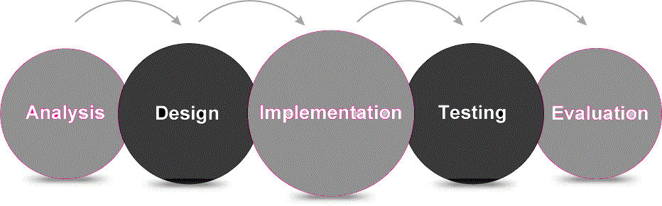

* **Analysis:** Before a program is created, they have to know what they want to create. To understand the nature of the program to be built we must understand the information domain for the software as well as required function behavior, performance and interface requirements for both the system.
* **Designing:**once the analysis is done now it’s time for designing. It is the process by which a person creates a specification of a software artifact, intended to accomplish goals, using a set of primitive components and subject to constraints. Software design usually involves problem solving and planning a software solution. This includes both low-level component and algorithm design and high-level, architecture design.
* **Coding:**The design must be translated in machine readable form. It performs this task. If design is performed in a detailed manner, code generation can be accomplished mechanically.
* **Testing:**once code has been generated, software testing begins. It is done before the release to the final audience. Software testing is meant to see how the software works under different conditions. Testing is done to understand if it will work correctly, partially fail to work properly, or totally fail to work properly. Each test may be used to see how one, or many, parts of the software work at a point in its development.
* Prescriptive process models define a distinct set of activities, actions, tasks, milestones, and work products, that are required to engineer high-quality software. They do provide a useful roadmap for software engineering work.
* We discuss here the strategy of the system development in detail as the Register and search Application is developed using this strategy.
* The SDLC method is classically thought of as the set of activities that Analyst, designer and user carry out to develop and implement an information system. This method consists of six steps. In most business situations the activities are all closely related, usually inseparable and even order of the steps in these activities may be difficult to determine. Different parts of the project can be in various phases at the same time, with some components undergoing analysis while other is at advanced design stages.

***PROJECT LIFE CYCLESDLC***

1. ***SYSTEM ANALYSIS:-***

**Problem Definition**

* Now a day’s people have not enough time to go in market and search for the required items
* In the modern time people are want each and every thing at their door step without consuming much time.
* Some time people have to pay high cost of product as products are sold in retail store.
* People are never like to stay in a que for purchasing or payment.
* An online item wills online shopping.
* I have done this project using PHP as front end and MYSQLi Server as back end easing the effort of user.

**Modules of the Project**

* ***Client Module:***
* Each of the citizens, who want to purchase online ordering shopping, must first register with the Software. For the registration part each person enters their details name, address, phone no, E-Mail ID, User Id & password in the Software.
* Once the registration is complete, the citizen can sign-in to the website & make purchasing of different product items.
* ***Administrators Module:***
* The module will be protected by user ID and password. Ordinary users of the software will not be permitted to enter into this area of the software.
* The module will be focusing on the maintenance like Master Data Maintenance, Removal of old and outdated data from the software etc.

**Requirement Analysis:-**

***(1)Function Requirement***

Organization has following basic requirements to be performed by the website. So, user can be able to get following functionality from website.

* Information about online order shopping system.
* Information about different types of items and category in our site.
* Available range of searching facility.
* Adm
* in can search client information.

**About existing manual system:**

* User can view every category & item and buy every shivam kitchenware item.
* User can not login without approval of Admin.
* User can view the also purchase a shivam kitchenware item.
* Admin can delete user.
* Admin also rights for the whole website.

**FEASIBILITY STUDIES**

* Feasibility study is most important and it concerns great to the customer, for which new system is to be developed.
* It includes the study of success and level of satisfaction that the customer and the user will get from the system. Feasibility means possibilities, i.e. this study explores the possibility of implementation of new system as a substitute to old system removing all shortcomings and including all new requirements.
* ***The feasibility study is needed to***
* Answer the question whether a new system is to be installed or not?
* Determine the potential of the existing system.
* Improve the existing system.
* Know what should be embedded in the new system.
* Define the problems and objective involved in a project.
* Avoid costly repairs at a later stage when the system is implemented.
* Avoid crash implementation of a new system.
* Avoid the ‘KitchenwareApproach’ i.e. getting a computer first and then deciding how to use it.
* An initial determine in a proposal that whether an alternative system is feasible or not. To determine of candidate system in all respect I need to consider following feasibility factors:

1. Operational feasibility
2. Technical feasibility
3. Economical feasibility
4. ***Technical Feasibility:***

* It is determined by the hardware and supporting software. Hardware requirements: stand-alone computer with enough main memory space & backup storage more than 2 GB to support MYSQLIi and huge database. Software requirement: MYSQLIi.
* **Minimum Hardware Requirement**

|  |  |
| --- | --- |
| Component | Minimum Requirement |
| 1.Processor | 1.6GHz processor  For above |
| 2.Suported Architecture | 32bit(* 86)  64*64 |
| 3.Memory | 512MB for above |
| 4.Hardisk | Total space 250GB  Installing space in single drive 5GB |

* **Minimum Software Requirement**

|  |  |
| --- | --- |
| Component | Minimum Requirement |
| 1.Operating System | Window XP or above |
| 2.PHP | Server side scripting language |
| 3.MYSQLi | Database |
| 4.Xampp | Web Application server |
| 5.Other Tools | Photoshop |
| 6.Web Browser | Microsoft IE 9.0,  Mozilla Firefox 48 |

1. ***Operational Feasibility:***

* Our application has such a user friendly GUI that any person having a sound knowledge ofhfh computer can operate the system.

|  |  |  |  |
| --- | --- | --- | --- |
| **Page** | **Process** | **Affected Table** | **Operation** |
| **1.Item** | Add,Updated,delete by admin | Login | Update |
| **2.Registration** | Upadate by user | Registration | Update |
| **3.Category** | Add,Update  And Delete by admin | Category | Add,Update  And Delete |
| **4.Product** | Add,Update  And Delete  By admin | Product | Add,Update  And Delete |
| **5.Contact** | Add by User | Contact | Add |

1. ***Economical Feasibility:***

|  |  |  |  |  |
| --- | --- | --- | --- | --- |
| Component | Minimum Requirement | Price | Local market Price | Website |
| 1.Processor | 1.6 GHz,  Intel Pentium | 1099 | 1200 | [www.ebay.in](http://www.ebay.in) |
| 2.Hardisk | 250GB | 2050 | 2200 | www.harddrive.in |
| 3.Memoryfh | 4GB RAM | 1997 | 2000 | [www.sanpdeal.com](http://www.sanpdeal.com) |
| 4.xampp |  | Free | Free | www.ebey.com |

**Software Requirement**

|  |  |  |
| --- | --- | --- |
| Component | Price | Website |
| 1.Window 7 OS | 8199 | [www.Infibean.com](http://www.Infibean.com) |
| 2.Add of Photoshop 7.0 | 5544 | [www.ebay.in](http://www.ebay.in) |
| 3.Mozilla Firefox | Free | [www.amazon.com](http://www.amazon.com) |
| 4.xampp | Free | [www.sanpdeal.com](http://www.sanpdeal.com) |
| 5.Dreamweaver | Free | [www.ebey.in](http://www.ebey.in) |

**Limitation of existing system:**

* Before we creating this BeautyZone Beauty Product web site, we were faces many problems.
* People don’t know about our one storage of BeautyZone Beauty Product which is selling an every type of items.
* So, people were purchase a item in different shop. So, her time is wasted.
* We were gives a many advertisement in news paper & TV.

**Scope of the purposed system:**

* This website has facility to view the purchase any items.
* User can also buy a many items.
* User can give feedback and ask some query to admin.
* Admin is authorized so while admin not approve user until user not login.
* This website is for all people who want to purchase any item..User first of all login.After login user can view item. After this user can send this opinion for this our web site.
* User can purchase the items and give feedback
* Admin can delete users.
* Admin can delete user and view user’s order.
* Our web site providing a case on delivery.
* So, user can do not hasisate while purchasing a item.

***DESING***

**DATA FLOW DIAGRAM**

* **A Data Flow Diagram (DFD) is a graphical representation of the "flow" of data through an Information System.**
* A data flow diagram can also be used for the visualization of Data Processing. It is common practice for a designer to draw a context-level DFD first which shows the interaction between the system and outside entities.

|  |  |  |
| --- | --- | --- |
| **DFD Symbols Description** | | |
| **Symbol Name** | **Shape** | **Description** |
| **External Entity** | **Entity** | The sharp cornered rectangles(or simply boxes) in a DFD indicates entities.  Entities are people things, organizations etc |
| **Process** |  | The Process symbol represents an activity that transforms or manipulates the data (combines, reorders, converts, etc.). |
| **Data Store** | C:\Users\poonam\Desktop\data flow diagram\New folder (2)\Untitled.png | Opened sided rectangles in DFD indicates data store.  A Data Store is a repository of data. |
| **DataF low** |  | Arrow symbol in DFD indicate data flow.  The Data Flow symbol represents movement of data |

* **Object Oriented Approach**
* ***Functional Modeling:-***
* ***Use case Diagram***

***(1) DFD for 0 levels***



***(2) DFD for Admin***



***(3) DFD for Client***



BeautyZone

* **Data Modeling:**
* ***Activity Diagram***
* **Activity diagram for Invalid User:**

Activity diagram for user registration process is described bel



**Activity diagram for Admin**



**Activity diagram for Client**



BeutyZone

**Traditional Approach**

* **ERDiagram**



* **Data Dictionary**
* ***DATABASE DETAIL***
* A **data dictionary** is as defined as a "centralized repository of information about data such as meaning, relationships to other data, origin, usage, and format. “
* A data dictionary can be consulted to understand where a data item fits in the structure, what values it may contain, and basically what the data item means in real-world terms.

**[1]Table Name : Login**

**Description : This table is used to store administration information.**

|  |  |  |
| --- | --- | --- |
| **Field Name** | **Data Type** | **Extra** |
| **Id** | Int(11) | Auto_increment |
| **Username** | Varchar(50) |  |
| **Password** | Varchar(50) |  |

**[2] Table Name: Registration**

**Description : This table is used to Registration Information.**

|  |  |  |
| --- | --- | --- |
| **Field Name** | **Data Type** | **Extra** |
| **Id** | Int(30) | Auto_increment |
| **FirstName** | Varchar(30) |  |
| **LastName** | Varchar(50) |  |
| **Address** | Varchar(100) |  |
| **Country** | Varchar(50) |  |
| **City** | Varchar(50) |  |
| **State** | Varchar(50) |  |
| **Contact no** | Int(30) |  |
| **E-mail** | Varchar(20) |  |
| **Username** | Varchar(10) |  |
| **Password** | Varchar(20) |  |

**[3] Table Name: Company**

**Description : This table is used to Company Information.**

|  |  |  |
| --- | --- | --- |
| **Field Name** | **Data Type** | **Extra** |
| **id** | Int(3) | Auto_increment |
| **name** | Varchar(30) |  |

**[4]Table Name : Item**

**Description : This table is used to store Item Information.**

|  |  |  |
| --- | --- | --- |
| **Field Name** | **Data Type** | **Extra** |
| **Item_Id** | Int(3) | Auto_increment |
| **Catagory** | Varchar(100) |  |
| **Itemnm** | Varchar(50) |  |
| **Itemdes** | Varchar(30) |  |
| **Price** | Varchar(50) |  |
| **Image** | Varchar(100) |  |

**[5] Table Name : Feedback**

**Description : This table is used to store customer Feedback information.**

|  |  |  |
| --- | --- | --- |
| **Field Name** | **Data Type** | **Extra** |
| **Id** | Int(3) | Auto_increment |
| **FirstName** | Varchar(30) |  |
| **LastName** | Varchar (20) |  |
| **Email** | Varchar(20) |  |
| **Feedback** | Varchar(50) |  |

**[6]Table Name : Addtocart**

**Description : This table is used to store addtocart Information.**

|  |  |  |
| --- | --- | --- |
| **Field Name** | **Data Type** | **Extra** |
| **Id** | Int(20) | Auto_increment |
| **Name** | Varchar(100) |  |
| **Price** | Int(50) |  |
| **Quantity** | Int(25) |  |
| **Total** | Int(20) |  |
| **Image** | Varchar(50) |  |
| **Username** | Varchar(40) |  |

**[7] Table Name :Purchase**

**Description : This table is used to store Purchase Information.**

|  |  |  |
| --- | --- | --- |
| **Field Name** | **Data Type** | **Extra** |
| **Id** | Int(20) | Auto_increment |
| **Name** | Varchar(100) |  |
| **Address** | Varchar (50) |  |
| **City** | Varchar (25) |  |
| **Item** | Int(20) |  |
| **Total** | Int (50) |  |
| **Payment** | Int (40) |  |

**IMPLEMENTATION &PLANING**

* ***Gantt Chart:-***

|  |  |  |  |  |  |  |  |  |  |  |  |  |  |  |  |  |
| --- | --- | --- | --- | --- | --- | --- | --- | --- | --- | --- | --- | --- | --- | --- | --- | --- |
| **ID** | **Task Name** | **Start** | **Finish** | **Duration** | June 2023 | | July 2024 | | | | Aug 2024 | | Sept 2024 | | Oct 2024 | |
| **19-06** | **02-07** | **05-07** | **20-07** | **21-07** | **31-07** | **01-08** | **29-08** | **30-09** | **14-09** | **15-09** | **05-10** |
| **1** | **Requirements Analysis** | **19-6-2024** | **02-7-2024** | **14d** |  | |  | | | | | | | | | |
| **2** | **Database design** | **05-7-2024** | **20-7-2024** | **15d** |  | |  | |  | | | | | | | |
| **3** | **Screendesign** | **21-7-2024** | **31-7-2024** | **11d** |  | | | |  | |  | | | | | |
| **4** | **Programming** | **01-8-2024** | **29-8-2024** | **4wk** |  | | | | | |  | |  | | | |
| **5** | **Testing** | **30-9-2024** | **14-9-2024** | **16d** |  | | | | | | | |  | |  | |
| **6** | **Userdocumentation** | **15-9-2024** | **5-10-2024** | **2wk** |  | | | | | | | | | |  | |

**Inpute & Output Design**

SCREEN LAYOUT

**ADMIN SIDE**

**Form :- login.php**

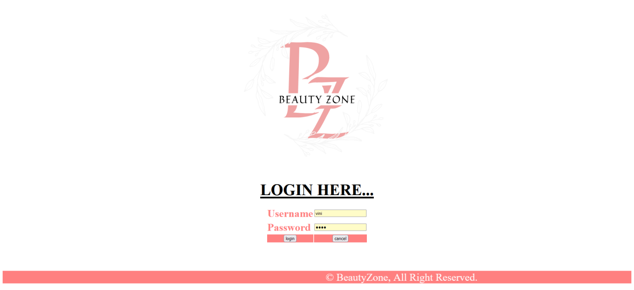

**Coding :-login.php**

<html>

<head>

<title>BeautyZone</title>

<link rel="stylesheet" href="css/style.css" type="text/css">

<meta http-equiv="Content-Type" content="text/html; charset=iso-8859-1">

</head>

<body>

<div align="center" marginheight="1">

<img src="image_project/LOGO.png"></img></div>

<br>

<center>

<h1 align="center"><font size="+6" color="#000000"><b><u>LOGIN HERE...</u></b></font></h1>

<form action="loginsave.php" method="post" name="login" onSubmit="return validateForm()">

<font size="+2" color="#FFFFFF">

<table align="center" size="80%" >

<tr>

<td><font size="+3" color="#FF8080"><b> Username </b></font></td>

<td><input type="text" name="username" height="50%" width="60%"></td>

</tr>

<tr>

<td><font size="+3" color="#FF8080"><b> Password </b></font></td>

<td><input type="password" name="password"></td>

</tr>

<tr>

<td align="center" bgcolor="#FF8080" colspan="1"><input name="submit" type="submit" value="login"></td>

<td align="center" bgcolor="#FF8080" colspan="1"><input name="submit" type="reset" value="cancel"></td>

</tr>

</table>

</form>

</center>

</font>

<tr>

<td>&nbsp;</td>

</tr>

</table>

<p>&nbsp;</p>

<div class="footer">

<font size="+3" color="white">

<div>

<marquee behavior="alternate" bgcolor="FF8080" height="+10">

&copy; BeautyZone, All Right Reserved.

</marquee>

</div>

</font>

</body>

</html>

**Form:-home.php**

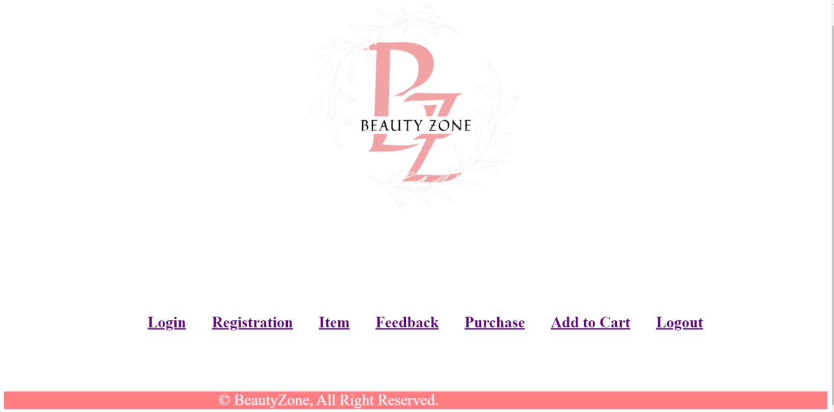

**Coding :- home.php**

<?php include("header.php"); ?>

<header class="navbar navbar-fixed-top">

<div class="navbar-inner">

<div class="container">

<link rel="icon" type="image/png" href="img/g2.png">

<a class="btn btn-navbar" data-toggle="collapse" data-target=".nav-collapse">

<span class="icon-bar"></span>

<span class="icon-bar"></span>

<span class="icon-bar"></span>

</a>

</ul>

</div>

</div>

</div>

</header>

<table align="Center" style='margin-top:180px'>

<tr>

<td><ul>

<h1 style="border-radius:15px 50px; padding:5px;">

<a href="loginmaster.php">Login</a></h1>

</ul></td>

<td><ul>

<h1 style="border-radius:15px 50px; padding:5px;">

<a href="registrationmaster.php">Registration</a></h1>

</ul></td>

<td><ul>

<h1 style="border-radius:15px 50px; padding:5px;">

<a href="itemmaster.php">Item</a></h1>

</ul></td>

<td><ul>

<h1 style="border-radius:20px 50px; padding:5px;">

<a href="feedbackmaster.php">Feedback</a></h1>

</ul></td>

<td><ul>

<h1 style="border-radius:20px 50px; padding:5px;">

<a href="purchasemaster.php">Purchase</a></h1>

</ul></td>

<td><ul>

<h1 style="border-radius:20px 50px; padding:5px;">

<a href="addtocartmaster.php">Add to Cart</a></h1>

</ul></td>

<td><ul>

<h1 style="border-radius:15px 50px; padding:5px;">

<a href="login.php">Logout</a></h1>

</ul></td>

</tr>

</table>

<?php include("footer.php"); ?>

**Form :- loginmaster.php**

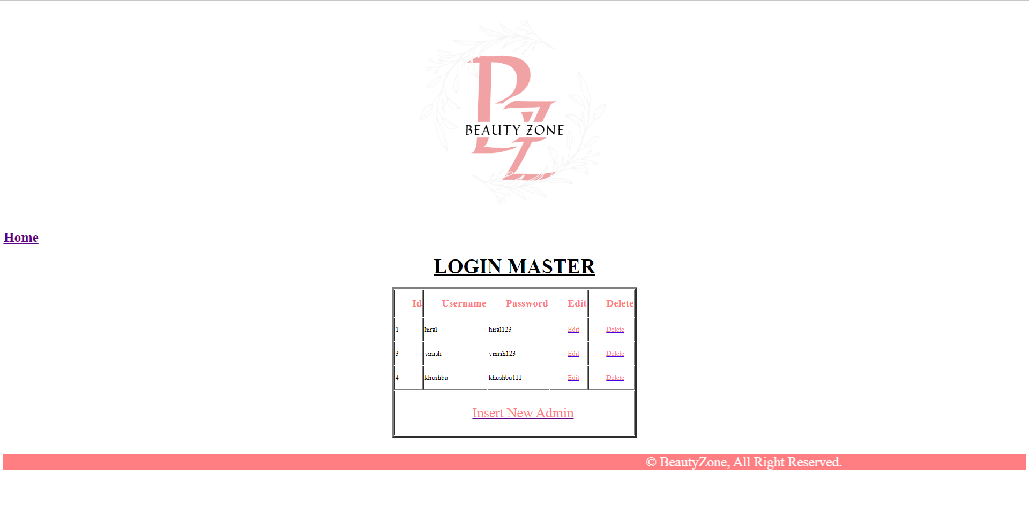

**Coding :- loginmaster.php**

<?php include("header.php"); ?>

<h1 align="center" class="hed">LOGIN MASTER</h1>

<?php

include("con1.php");

$query="select * from login";

$result=mysqli_query($con,$query);

echo"<table cellpadding='6' class='tbl' align='center' cellspacing='6' border='5' bgcolor='#CCFF99'>

<tr class='th1'>

<th>Id</th>

<th>Username</th>

<th>Password</th>

<th>Edit</th>

<th>Delete</th>

</tr>";

while($row=mysqli_fetch_array($result))

{

echo "<tr><td>";

echo $row["id"];

echo "</td><td>";

echo $row["username"];

echo "</td><td>";

echo $row["password"];

echo"</td><td>

<ahref='loginedit.php?id=".$row[0]."'>Edit</a></td><td>

<a href='logindelete.php?id=".$row[0]."'>Delete</a></td></tr>"; }

echo"<tr><td colspan='5' align='center'>

<a href='logininsert.php'>Insert New Admin</a></td></tr></table>";?>

<?php include("footer.php"); ?>

**Form :- logininsert.php**

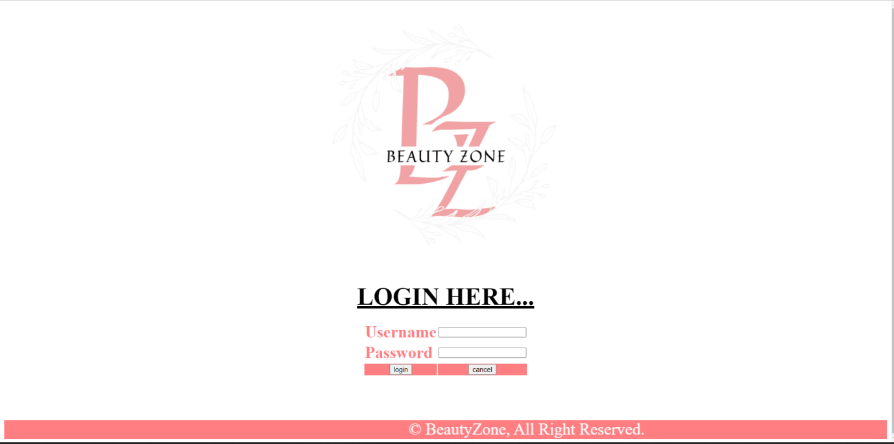

**Coding :- logininsert.php**

<!DOCTYPE html><head>

<meta charset="utf-8">

<meta http-equiv="X-UA-Compatible" content="IE=edge,chrome=1">

<link rel="apple-touch-icon" sizes="76x76" href="file:///C|/xampp/htdocs/ladies_bags/project/admin/img/g2.png">

<link rel="shortcut icon" href="file:///C|/xampp/htdocs/ladies_bags/project/admin/images/favicon.png">

<header class="navbar navbar-fixed-top">

<div class="navbar-inner">

<div class="container">

<link rel="icon" type="image/png" href="file:///C|/xampp/htdocs/ladies_bags/project/admin/img/g2.png">

<a class="btn btn-navbar" data-toggle="collapse" data-target=".nav-collapse">

<span class="icon-bar"></span>

<span class="icon-bar"></span>

<span class="icon-bar"></span>

</a>

<title>BeautyZone</title>

<script type="text/javascript">

function validateForm()

{

var a=document.forms["login"]["username"].value;

var b=document.forms["login"]["password"].value;

if ((a==null || a=="") && (b==null || b=="")

if (a==null || a=="")

{

alert("username must be filled out");

return false;

}

if (b==null || b=="")

{

alert("password must be filled out");

return false;

}

if(b.length<5)

{

alert("password should be atleast 5 characters.");

return false;

}

if(!(b.match(/^[a-z,0-9][\w-]*$/i)))

{

alert("Password can not contain any special character or spaces except '_' or '-' . ");

return false;

}

}

</script>

</head>

<body>

<div align="center" marginheight="1">

<img src="image_project/LOGO.png"></img></div>

<script src="file:///C|/xampp/htdocs/ladies_bags/project/admin/js/vendor/jquery-1.9.1.min.js"></script>

<script src="file:///C|/xampp/htdocs/ladies_bags/project/admin/js/main.js"></script>

<script src="file:///C|/xampp/htdocs/ladies_bags/project/admin/js/jquery.ba-cond.min.js"></script>

<script src="file:///C|/xampp/htdocs/ladies_bags/project/admin/js/jquery.slitslider.js"></script>

<!-- Slider -->

<script type="text/javascript">

$(function() {

var Page = (function() {

var $navArrows = $( '#nav-arrows' ),

slitslider = $( '#slider' ).slitslider( {

autoplay : true

} ),

init = function() {

initEvents();

},

initEvents = function() {

$navArrows.children( ':last' ).on( 'click', function() {

slitslider.next();

return false;

});

$navArrows.children( ':first' ).on( 'click', function() {

slitslider.previous();

return false;

});

};

return { init : init };

})();

Page.init();

});

</script>

<!-- /Slider -->

<br><br>

<center>

<h1 align="center"><font size="+6" color="#000000"><b><u> new admin login </u></b></font></h1>

<form action="loginsave.php" method="post" name="login"

onSubmit="return validateForm()">

<font size="+2" color="#FFFFFF">

<table align="center" size="80%" >

<tr>

<td><font size="+3" color="#FF8080"><b> Username </b></font></td>

<td><input type="text" name="username" height="50%" width="60%">

</td>

</tr>

<tr>

<td><font size="+3" color="#FF8080"><b> Password </b></font></td>

<td><input type="password" name="password"></td>

</tr>

<tr>

<td align="center" bgcolor="#FF8080" colspan="+2"><input name="submit" type="submit" value="INSERT"></td>

</tr>

</table>

</form>

</center>

<?php include("footer.php"); ?>

**Coding :- checklogin.php**

<?php

include("con1.php");

$username=$_POST['username'];

$password=$_POST['password'];

if($username==" "|| $password==" ")

{

header("location:login.php");

}

else

{

$query="select * from login where username='$username' and password='$password'";

$result=mysqli_query($con,$query);

$res=mysqli_fetch_array($result);

$count=mysqli_num_rows($result);

if($count==0)

{

?>

<script type="text/javascript">

alert("In valid username or password");

window.location.herf="login.php";

</script>

<?php

}

else

{

session_start();

$_SESSION['username']=$urername;

?>

<script type="text/javascript">

alert("location successfully");

window.location.href="home.php"

</script>

<?php

}

}

?>

**Coding:- con1.php**

<?php

$con=mysqli_connect("localhost","root","");

mysqli_select_db($con,"beautyzone");

?>

**Form :- loginedit.php**

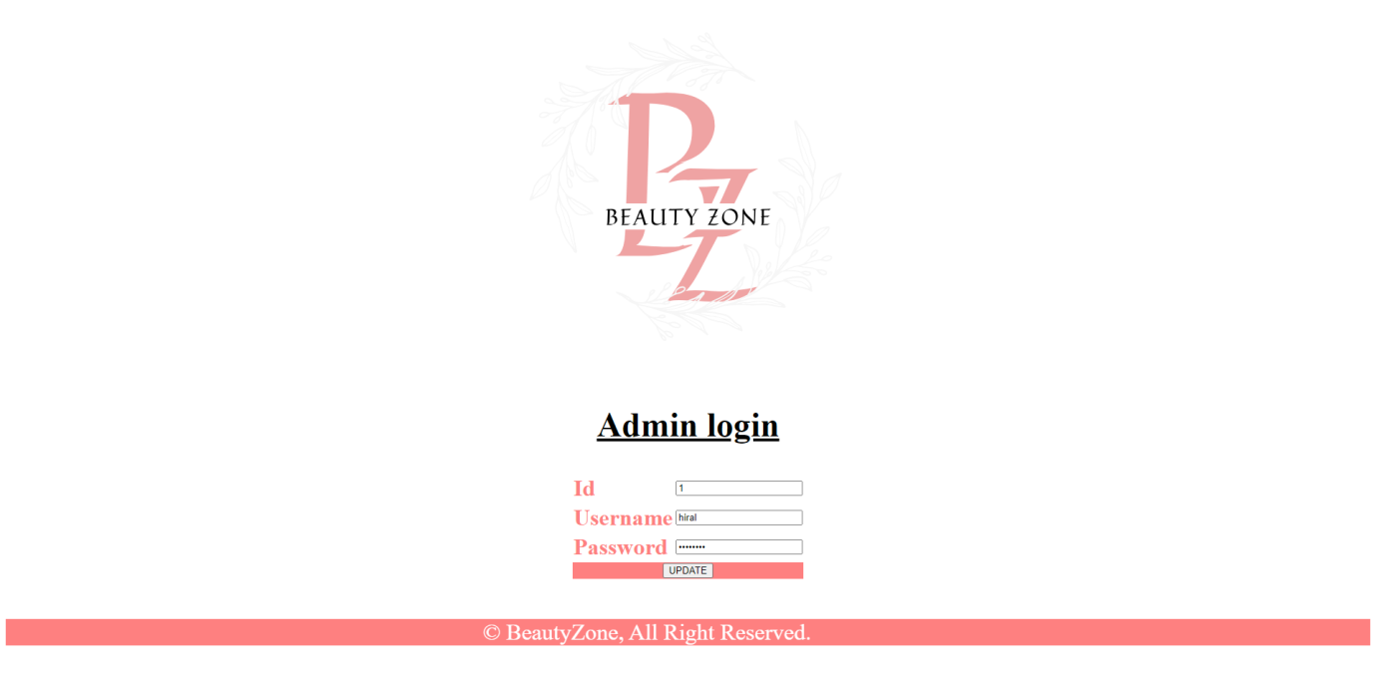

**Coding :- loginedit.php**

<!DOCTYPE html>

<head>

<meta charset="utf-8">

<meta http-equiv="X-UA-Compatible" content="IE=edge,chrome=1">

<title>BeautyZone</title>

<script type="text/javascript">

function validateForm()

{

var a=document.forms["loin"]["username"].value;

var b=document.forms["login"]["password"].value;

if ((a==null || a=="") && (b==null || b=="")

if (a==null || a=="")

{

alert("username must be filled out");

return false;

}

if (b==null || b=="")

{

alert("password must be filled out");

return false;

}

if(b.length<5)

{

alert("password should be atleast 5 characters.");

return false;

}

if(!(b.match(/^[a-z,0-9][\w-]*$/i)))

{

alert("Password can not contain any special character or spaces except '_' or '-' . ");

return false;

}

}

</script>

</head>

<body>

<img src="image_project/LOGO.png"alt=""width="1500" height="300" align="center">

<script src="js/vendor/jquery-1.9.1.min.js"></script>

<script src="js/main.js"></script>

<script src="js/jquery.ba-cond.min.js"></script>

<script src="js/jquery.slitslider.js"></script>

<!-- Slider -->

<script type="text/javascript">

$(function() {

var Page = (function() {

var $navArrows = $( '#nav-arrows' ),

slitslider = $( '#slider' ).slitslider( {

autoplay : true

} ),

init = function() {

initEvents();

},

initEvents = function() {

$navArrows.children( ':last' ).on( 'click', function() {

slitslider.next();

return false;

});

$navArrows.children( ':first' ).on( 'click', function() {

slitslider.previous();

return false;

});

};

return { init : init };

})();

Page.init();

});

</script>

<!-- /Slider -->

<?php

include("con1.php");

$id=$_GET['id'];

$query="select * from login where id=$id";

$result=mysqli_query($con,$query);

while($row=mysqli_fetch_array($result))

{

?>

<br><br>

<form action="logineditsave.php" method="post" enctype="multipart/form-data"

name="login" onSubmit="return validateForm()">

<h1 align="center"><font size="+6" color="#000000"><b><u> Admin login </u></b></font></h1>

<table align="center">

<tr>

<td><font size="+3" color="#FF8080"><b> Id </td>

<td><input type="text" name="id"value="<?php echo $row['0'];?>"></td>

</tr><br>

<tr>

<td><font size="+3" color="#FF8080"><b> Username </b></font></td>

<td><input type="text" name="username" value="<?php echo $row['1'];?>"></td>

</tr>

<tr>

<td><font size="+3" color="#FF8080"><b> Password </b></font></td>

<td><input type="password" name="password" value="<?php echo $row['2'];?>"></td>

</tr>

<tr>

<td align="center" bgcolor="#FF8080" colspan="+2"><input name="submit" type="submit" value="UPDATE">

</td>

</tr>

</table>

<br><br><br>

<font size="+3" color="white">

<div>

<marquee behavior="alternate" bgcolor="#FF8080" height="+10">

&copy; BeautyZone, All Right Reserved.

</marquee>

</div>

</font>

</form>

<?php

}

?>

</html>

</body>

</html>

**Coding :- logindelete.php**

<?php

session_start();

if(!isset($_SESSION['username']))

{

header("location:login.php");

}

else

{

?>

<?php

include("con1.php");

$id=$_GET['id'];

$query="DELETE FROM `login` WHERE `login`.`id` = $id";

mysqli_query($con,$query);

header("location:loginmaster.php");

?>

<?php

}

?>

**Form :- registration.php**

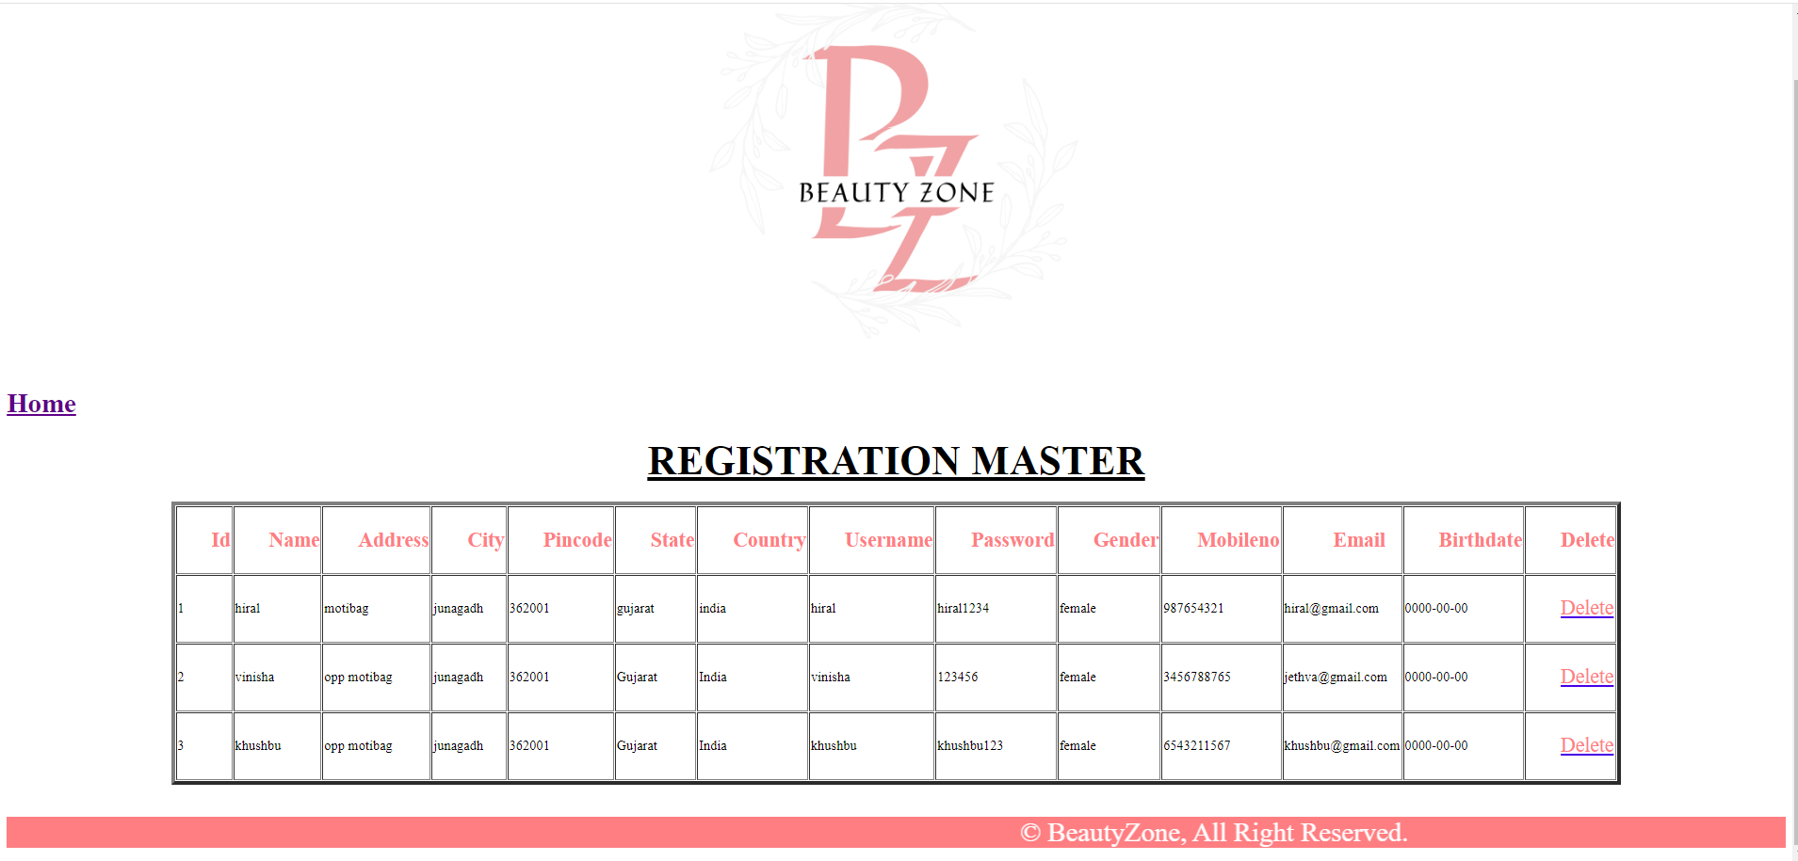

**Coding :- registrationmaster.php**

<!DOCTYPE html>

<head>

<title>BeautyZone</title>

</head>

<body>

<div align="center" >

<img src="image_project/LOGO.png"></img></div>

<script src="js/vendor/jquery-1.9.1.min.js"></script>

<script src="js/main.js"></script>

<script src="js/jquery.ba-cond.min.js"></script>

<script src="js/jquery.slitslider.js"></script>

<a href="home.php"><h1><b>Home</b></h1></a>

<?php

include("con1.php");

$query="select * from registration";

$result=mysqli_query($con,$query);

echo"<table align='center' border='5' >

<h1 align='center'>

<font color='black' size='+5'>

<u> REGISTRATION MASTER </u></font>

</h1>

<th>

<font color='FF8080' size='+2'><ul>Id</ul></font>

</th>

<th>

<font color='FF8080' size='+2'><ul>Name</font></ul>

</th>

<th>

<font color='FF8080' size='+2'><ul>Address</font></ul>

</th>

<th>

<font color='FF8080' size='+2'><ul>City</font></ul>

</th>

<th>

<font color='FF8080' size='+2'><ul>Pincode</font></ul>

</th>

<th>

<font color='FF8080' size='+2'><ul>State</font></ul>

</th>

<th>

<font color='FF8080' size='+2'><ul>Country</font></ul>

</th>

<th>

<font color='FF8080' size='+2'><ul>Username</font></ul>

</th>

<th>

<font color='FF8080' size='+2'><ul>Password</font></ul>

</th>

<th>

<font color='FF8080' size='+2'><ul>Gender</font></ul>

</th>

<th>

<font color='FF8080' size='+2'><ul>Mobileno</font></ul>

</th>

<th>

<font color='FF8080' size='+2'><ul>Email</font></ul>

</th>

<th>

<font color='FF8080' size='+2'><ul>Birthdate</font></ul>

</th>

<th>

<font color='FF8080' size='+2'><ul>Delete</font></ul></th>";

while($row=mysqli_fetch_array($result))

{

echo"<tr><td>";

echo $row["id"];

echo "</td><td>";

echo $row["name"];

echo "</td><td>";

echo $row["address"];

echo "</td><td>";

echo $row["city"];

echo "</td><td>";

echo $row["pincode"];

echo "</td><td>";

echo $row["state"];

echo "</td><td>";

echo $row["country"];

echo "</td><td>";

echo $row["username"];

echo "</td><td>";

echo $row["password"];

echo "</td><td>";

echo $row["gender"];

echo "</td><td>";

echo $row["mobileno"];

echo "</td><td>";

echo $row["email"];

echo "</td><td>";

echo $row["dob"];

echo "</td><td>

<a href='registrationdelete.php?id=".$row[0]."'>

<font color='FF8080'size='5'><ul>Delete</ul></font></a></td>";

}

echo"</tr></table>";

?>

</div>

<br><br>

<font size="+3" color="white">

<div>

<marquee behavior="alternate" bgcolor="#FF8080" height="+10">

&copy; BeautyZone, All Right Reserved.</marquee>

</div>

</font>

</body>

**registrationdelete.php**

<?php

include("con1.php");

$id=$_GET['id'];

$name=$_GET['nm'];

$address=$_GET['address'];

$city=$_GET['city'];

$pincode=$_GET['pincode'];

$state=$_GET['state'];

$country=$_GET['country'];

$username=$_GET['username'];

$password=$_GET['password'];

$gender=$_GET['gender'];

$mno=$_GET['mno'];

$email=$_GET['email'];

$dob=$_GET['dob'];

$query="DELETE FROM `registration` WHERE `registration`.`id` = '$id'";

mysqli_query($con,$query);

header("location:registrationmaster.php");

?>

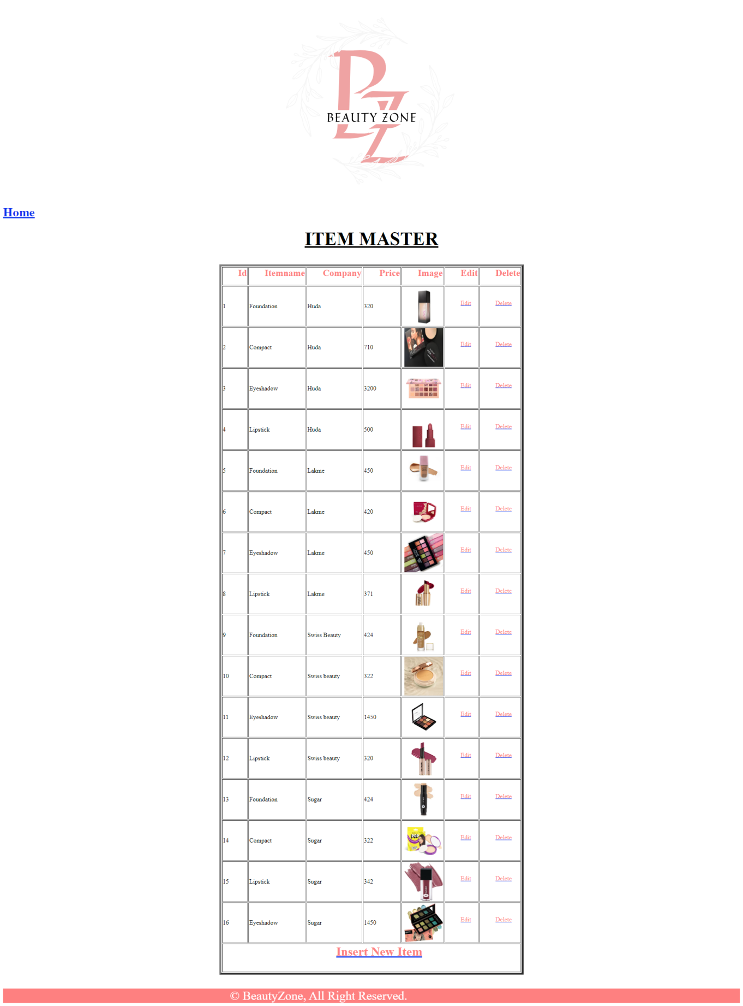**Form :- itemsmaster.php**

**Coding :- itemsmaster.php**

<?php include("header.php"); ?>

<?php

?>

</body>

</html>

<a href="home.php"><h1><b>Home</b></h1></a>

<?php

include("con1.php");

$query="select *from items";

$result=mysqli_query($con,$query);

echo"<table border='5' align='center'>

<h1 align='center'><font color='000000' size='+5'><u> ITEM MASTER </u></font></h1>

<th><font color='FF8080' size='+2'><ul>Id</font></ul></th>

<th><font color='FF8080' size='+2'><b><ul>Itemname</font></ul></th>

<th><font color='FF8080' size='+2'><b><ul>Company</font></ul></th>

<th><font color='FF8080' size='+2'><b><ul>Price</font></ul></th>

<th><font color='FF8080' size='+2'><b><ul>Image</font></ul></th>

<th><font color='FF8080' size='+2'><b><ul>Edit</font></ul></th>

<th><font color='FF8080' size='+2'><b><ul>Delete</font></ul></th>";

while($row=mysqli_fetch_array($result))

{

echo"<tr><td>";

echo $row["id"];

echo "</td><td>";

echo $row["itemname"];

echo "</td><td>";

echo $row["company"];

echo "</td><td>";

echo $row["price"];

echo "</td><td>";

echo "<img src='image_project/$row[4]' height=100 width=100 style='margin-left:5px'>";

echo "</td><td><a href='itemedit.php? id=".$row[0]."'><font color='FF8080'><ul> Edit </ul></font></a></td>

<td><a href='itemdelete.php?id=".$row[0]."'><font color='FF8080'><ul> Delete </ul></font></a></td>";

}

echo"</tr>";

echo"<br>";

echo"<td colspan='10' align='center'><a href='item.php'><h1><font color='FF8080'><ul> Insert New Item </ul></font></h1></a></td>";

echo"</table>";

?>

<?php include("footer.php"); ?>

**Form :- item.php**

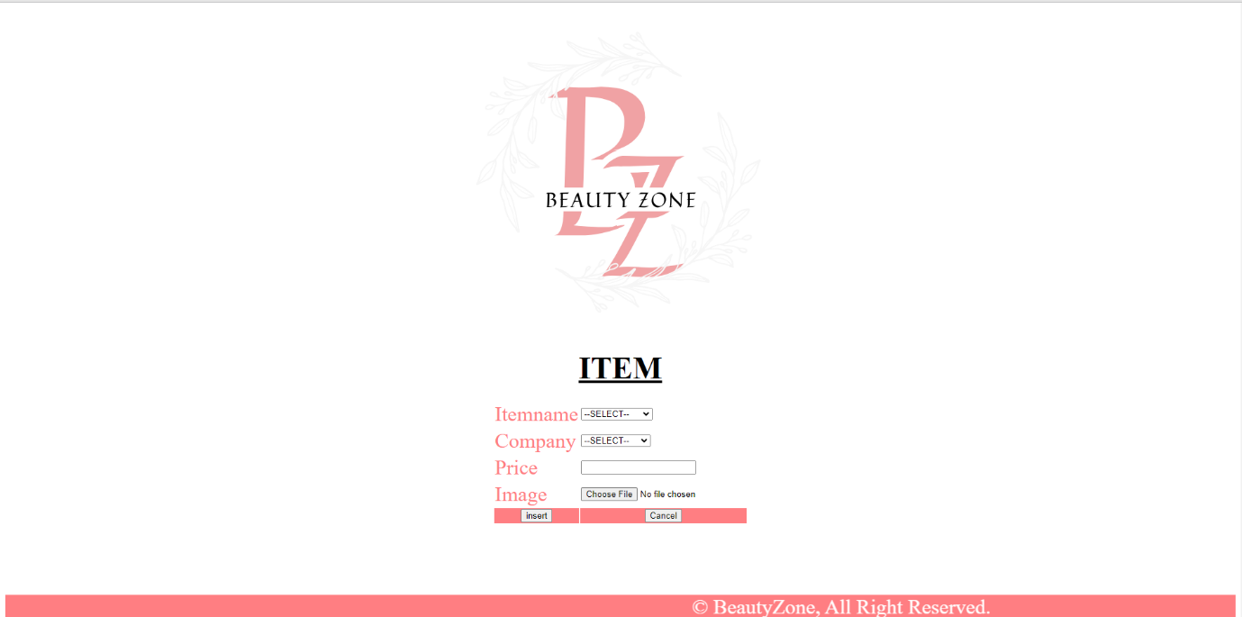

**Coding:-item.php**

<!DOCTYPE html>

<head>

<meta charset="utf-8">

<meta http-equiv="X-UA-Compatible" content="IE=edge,chrome=1">

<title>BeautyZone</title>

<script type="text/javascript">

function validateForm()

{

var a=document.forms["itm"]["itemname"].value;

var b=document.forms["itm"]["company"].value;

var d=document.forms["itm"]["price"].value;

var e=document.forms["itm"]["image"].value;

if ((a==null || a=="") && (b==null || b=="") && (c==null || c=="") && (d==null || d=="") && (e==null || e==""))

{

alert("All Field must be filled out");

return false;

}

if (a==null || a=="")

{

alert("itemname must be filled out");

return false;

}

if (b==null || b=="")

{

alert("company must be filled out");

return false;

}

if (d==null || d=="")

{

alert("price must be filled out");

return false;

}

if (e==null || e=="")

{

alert("image must be filled out");

return false;

}

}

</script>

</head>

<body>

<div align="center" marginheight="1">

<img src="image_project/LOGO.png"></img></div>

<script src="js/vendor/jquery-1.9.1.min.js"></script>

<script src="js/main.js"></script>

<script src="js/jquery.ba-cond.min.js"></script>

<script src="js/jquery.slitslider.js"></script>

<!-- Slider -->

<script type="text/javascript">

$(function() {

var Page = (function() {

var $navArrows = $( '#nav-arrows' ),

slitslider = $( '#slider' ).slitslider( {

autoplay : true

} ),

init = function() {

initEvents();

},

initEvents = function() {

$navArrows.children( ':last' ).on( 'click', function() {

slitslider.next();

return false;

});

$navArrows.children( ':first' ).on( 'click', function() {

slitslider.previous();

return false;

});

};

return { init : init };

})();

Page.init();

});

</script>

<h1 align='center'>

<font color='#000000' size='+5'><u> ITEM </u></font>

</h1>

<form action="itemsave.php" method="post" enctype="multipart/form-data"name="itm"

onSubmit="return validateForm()">

<table align="center" >

<tr>

<td>

<font color='FF8080' size='+3'> Itemname </font>

</td>

<td><select name="itemname">

<option>--SELECT--</option>

<option>Compact</option>

<option>Eyeshadow</option>

<option>Foundation</option>

<option>Lipstick</option>

</select></td>

</tr>

<tr>

<td>

<font color='FF8080' size='+3'> Company </font>

</td>

<td>

<select name="Company">

<option>--SELECT--</option>

<option>Sugar</option>

<option>Huda </option>

<option>Lakme</option>

<option>Swiss Beauty</option>

</select>

</td>

</tr>

<tr>

<td>

<font color='FF8080' size='+3'> Price </font>

</td>

<td>

<input type="text" name="price"></td>

</tr>

<tr>

<td>

<font color='FF8080' size='+3'> Image </font>

</td>

<td>

<input type="file" name="image">

</td>

</tr>

<tr>

<td align="center" bgcolor="#FF8080">

<input name="submit" type="submit" value="insert">

</td>

<td align="center" bgcolor="#FF8080">

<input name="reset" type="reset" value="Cancel">

</td>

</tr>

</table>

</form>

<br><br><br><br><br><br>

<font size="+3" color="white">

<div>

<marquee behavior="alternate" bgcolor="#FF8080" height="+10">

&copy; BeautyZone, All Right Reserved.</marquee>

</div>

</font>

</body>

</html>

**Coding:- itemsave.php**

<?php

include("con1.php");

$itemname=$_POST['itemname'];

$category=$_POST['Company'];

$price=$_POST['price'];

$image=$_FILES['image']['name'];

move_uploaded_file($_FILES['image']['tmp_name'],"image_project/".$image);

mysqli_query($con,"INSERT INTO `items`( `itemname`,`Company`, `price`, `image`)

VALUES ('$itemname','$Company', '$price', '$image')");

header("location:itemmaster.php");

?>

**Form :- itemedit.php**

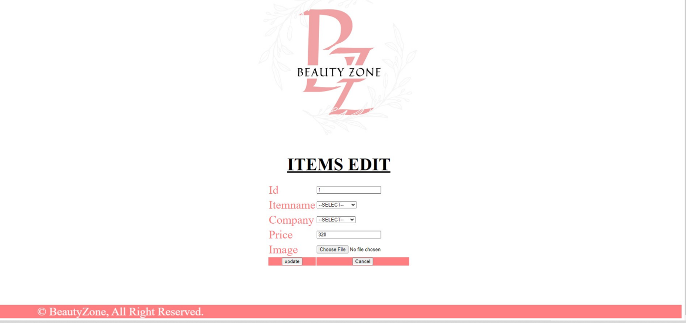

**Coding :- itemedit.php**

<head>

<meta charset="utf-8">

<meta http-equiv="X-UA-Compatible" content="IE=edge,chrome=1">

<title>BeautyZone</title>

<script type="text/javascript">

function validateForm()

{

var a=document.forms["itm"]["itemname"].value;

var b=document.forms["itm"]["category"].value;

var d=document.forms["itm"]["price"].value;

var e=document.forms["itm"]["image"].value;

if ((a==null || a=="") && (d==null || d=="") &&

(e==null || e==""))

{

alert("All Field must be filled out");

return false;

}

if (a==null || a=="")

{

alert("itemname must be filled out");

return false;

}

if (d==null || d=="")

{

alert("price must be filled out");

return false;

}

if (e==null || e=="")

{

alert("image must be filled out");

return false;

}

}

</script>

</head>

<body>

<div align="center" marginheight="1">

<img src="image_project/LOGO.png"></img></div>

<script src="js/vendor/jquery-1.9.1.min.js"></script>

<script src="js/main.js"></script>

<script src="js/jquery.ba-cond.min.js"></script>

<script src="js/jquery.slitslider.js"></script>

<script type="text/javascript">

$(function() {

var Page = (function() {

var $navArrows = $( '#nav-arrows' ),

slitslider = $( '#slider' ).slitslider( {

autoplay : true

} ),

init = function() {

initEvents();

},

initEvents = function() {

$navArrows.children( ':last' ).on( 'click', function() {

slitslider.next();

return false;

});

$navArrows.children( ':first' ).on( 'click', function() {

slitslider.previous();

return false;

});

};

return { init : init };

})();

Page.init();

});

</script>

<?php

include("con1.php");

$id=$_GET['id'];

$query="select * from items where id=$id";

$result=mysqli_query($con,$query);

while($row=mysqli_fetch_array($result))

{

?>

<form action="itemeditsave.php" method="post" enctype="multipart/form-data">

<h1 align="center"><font color='#000000' size='+5'><u> ITEMS EDIT </u></font></h1>

<table align="center" >

<tr>

<td><font color='FF8080' size='+3'> Id </font></td>

<td><input type="text" name="id"value="<?php echo $row['0'];?>"></td>

</tr>

<tr>

<td><font color='FF8080' size='+3'> Itemname</td>

<td><select name="itemname" value="<?php echo $row['1'];?>">

<option>--SELECT-- </option>

<option>Compect</option>

<option>Eyeshadow</option>

<option>Foundation</option>

<option>Lipstick</option>

</select></td>

</tr>

<tr>

<td ><font color='FF8080' size='+3'> Company </font></td>

<td><select name="Company" value="<?php echo $row['2'];?>">

<option>--SELECT--</option>

<option>Sugar</option>

<option>Huda</option>

<option>Lakme</option>

<option>Swiss Beauty</option>

</select></td>

</tr>

<tr>

<td><font color='FF8080' size='+3'> Price </font></td>

<td><input type="text" name="price" value="<?php echo $row['3'];?>"></td>

</tr>

<tr>

<td><font color='FF8080' size='+3'> Image </font></td>

<td><input type="file" name="image" value="<?php echo $row['4'];?>"></td>

</tr>

<tr>

<td align="center" bgcolor="#FF8080">

<input name="submit" type="submit" value="update">

</td>

<td align="center" bgcolor="#FF8080">

<input name="reset" type="reset" value="Cancel">

</td>

</tr>

</table>

<br><br></center>

</form>

<?php

}

?>

<?php include("footer.php"); ?>

**Coding :- itemeditsave.php**

<?php

include("con1.php");

$id=$_POST['id'];

$itemname=$_POST['itemname'];

$Company=$_POST['Company'];

$size=$_POST['size'];

$price=$_POST['price'];

$image=$_FILES['image']['name'];

move_uploaded_file($_FILES['image']['tmp_name'],"image_project/".$image);

$query="UPDATE `items` SET `Itemname` = '$itemname', `Company` = '$Company', `price` = '$price', `image` = '$image' WHERE `items`.`id` = $id";

mysqli_query($con,$query);

header("location:itemmaster.php");

if($result==NULL)

{?>

<script>

alert("Record Not Updated");

window location="itemmaster.php";

</script>

<?php

}

else

{

header("location:itemmaster.php");

}

?>

**Coding :- itemdelete.php**

<?php

include("con1.php");

$id=$_GET['id'];

$query="DELETE FROM `items` WHERE `items`.`id` = $id";

mysqli_query($con,$query);

header("location:itemmaster.php");

?>

**Form :- feedback.php**

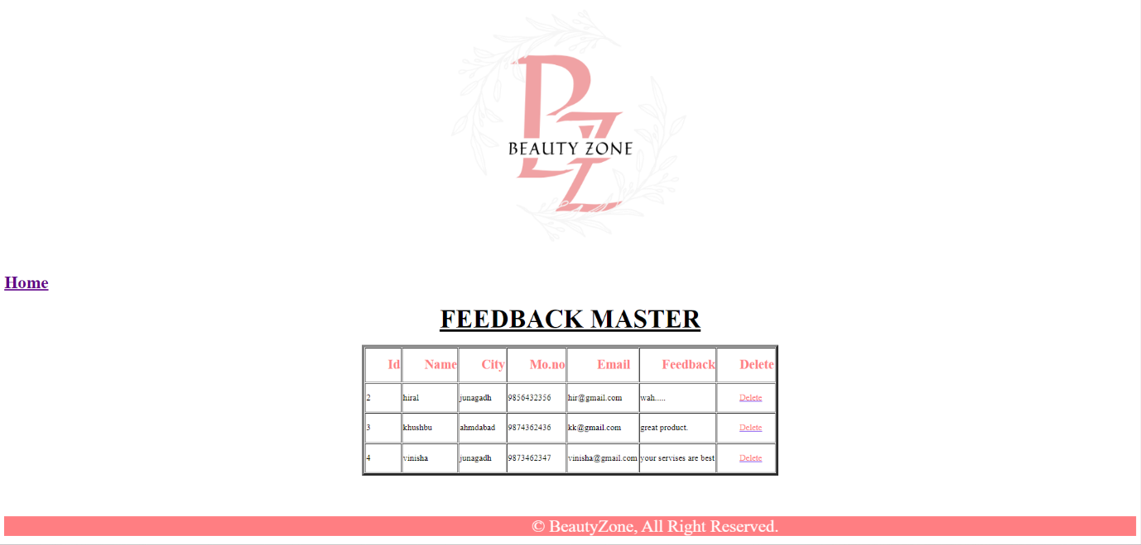

**Coding:- feedback.php**

<!DOCTYPE html>

<head>

<meta charset="utf-8">

<meta http-equiv="X-UA-Compatible" content="IE=edge,chrome=1">

<title>BeautyZone</title>

<script type="text/javascript">

function validateForm()

{

var a=document.forms["feedback"]["nm"].value;

var b=document.forms["feedback"]["city"].value;

var c=document.forms["feedback"]["mno"].value;

var d=document.forms["feedback"]["email"].value;

var e=document.forms["feedback"]["feed"].value;

if ((a==null || a=="") && (b==null || b=="") && (c==null || c=="") && (d==null || d=="") &&(e==null || e=="") )

{

alert("All Field must be filled out");

return false;

}

if (a==null || a=="")

{

alert("name must be filled out");

return false;

}

if (b==null || b=="")

{

alert("city must be filled out");

return false;

}

if (c==null || c=="")

{

alert("mno must be filled out");

return false;

}

if(!(c.match(/^\d{10}$/)))

{

alert("invalid mobile number");

return false;

}

if (d==null || d=="")

{

alert("email must be filled out");

return false;

}

if(!(d.match(/^[\w]+([_|\.-][\w]{1,})*@[\w]{2,}([_|\.-][\w]{1,})*\.([a-z]{2,4})$/)))

{

alert("enter valid email id");

return false;

}

if (e==null || e=="")

{

alert("feedback must be filled out");

return false;

}

}

</script>

<meta name="description" content="">

<meta name="keywords" content="">

<meta name="viewport" content="width=device-width">

<link rel="stylesheet" href="css/bootstrap.min.css">

<link rel="stylesheet" href="css/bootstrap-responsive.min.css">

<link rel="stylesheet" href="css/font-awesome.min.css">

<link rel="stylesheet" href="css/main.css">

<link rel="stylesheet" href="css/sl-slide.css">

<script src="js/vendor/modernizr-2.6.2-respond-1.1.0.min.js"></script>

<link rel="shortcut icon" href="img/g2.png">

</head>

<body>

<script src="js/vendor/jquery-1.9.1.min.js"></script>

<script src="js/main.js"></script>

<script src="js/jquery.ba-cond.min.js"></script>

<script src="js/jquery.slitslider.js"></script>

<!-- Slider -->

<script type="text/javascript">

$(function() {

var Page = (function() {

var $navArrows = $( '#nav-arrows' ),

slitslider = $( '#slider' ).slitslider( {

autoplay : true

} ),

init = function() {

initEvents();

},

initEvents = function() {

$navArrows.children( ':last' ).on( 'click', function() {

slitslider.next();

return false;

});

$navArrows.children( ':first' ).on( 'click', function() {

slitslider.previous();

return false;

});

};

return { init : init };

})();

Page.init();

});

</script>

<form action="feedbacksave.php" method="post" name="feedback" onSubmit="return validateForm()">

<h1 align='center'>

<font color='black' size='+5'><u> feedback </u></font>

</h1>

<table align="center">

<tr>

<td>

<font size="+2" color="#FF9900">Name</td></font>

<td>

<input type="text" name="nm">

</td>

</tr>

<tr>

<td>

<font size="+2" color="#FF9900">City</td>

<td>

<input type="text" name="city">

</td>

</tr>

<tr>

<td>

<font size="+2" color="#FF9900">Mno</td>

<td>

<input type="text" name="mno">

</td>

</tr>

<tr>

<td>

<font size="+2" color="#FF9900">Email</td>

<td>

<input type="text" name="email">

</td>

</tr>

<tr>

<td><font size="+2" color="#FF9900">Feedback</td>

<td>

<textarea name="feed"></textarea>

</td>

</tr>

<tr>

<td colspan="+2" align="center">

<button style="width:40%; height:60%;">

<input type="submit" name="feedback" value="FEEDBACK"></button>

<button style="width:40%; height:60%;">

<input type="reset" name="cancel" value="CANCEL"></td></button>

</tr>

</table>

</form>

</body>

</html>

<br><br>

**Coding:-feedbackdelete.php**

<?php

include("con1.php");

$id=$_GET['id'];

$query="DELETE FROM `feedback` WHERE `feedback`.`id` = $id";

mysqli_query($con,$query);

header("location:feedbackmaster.php");

?>

**Coding:- logout.php**

<?php

session_start();

if(!isset($_SESSION['username']))

{

?>

<script type="text/javascript"

window.location.href="login.php";

</script>

<?php

}

else

{

session_destroy();

?>

<script type="text/javascript">

window.location.href="login.php"

</script>

<?php

}

?>

**Coding :- header.php**

<html>

<head>

<title>BeautyZone</title>

<link rel="stylesheet" href="css/style.css" type="text/css">

<meta http-equiv="Content-Type" content="text/html; charset=iso-8859-1">

</head>

<body background="back.jpg">

<div align="center" marginheight="1">

<img src="image_project/LOGO.png"></img>

</div>

</body>

</html>

**Coding:-footer.php**

<div class="footer">

<font size="+3" color="white">

<div>

<marquee behavior="alternate" bgcolor="FF8080" height="+10">&copy; BeautyZone, All Right Reserved.</marquee>

</div>

</font>

</body>

</html>

**CLIENT SIDE**

**Form :- index.php**

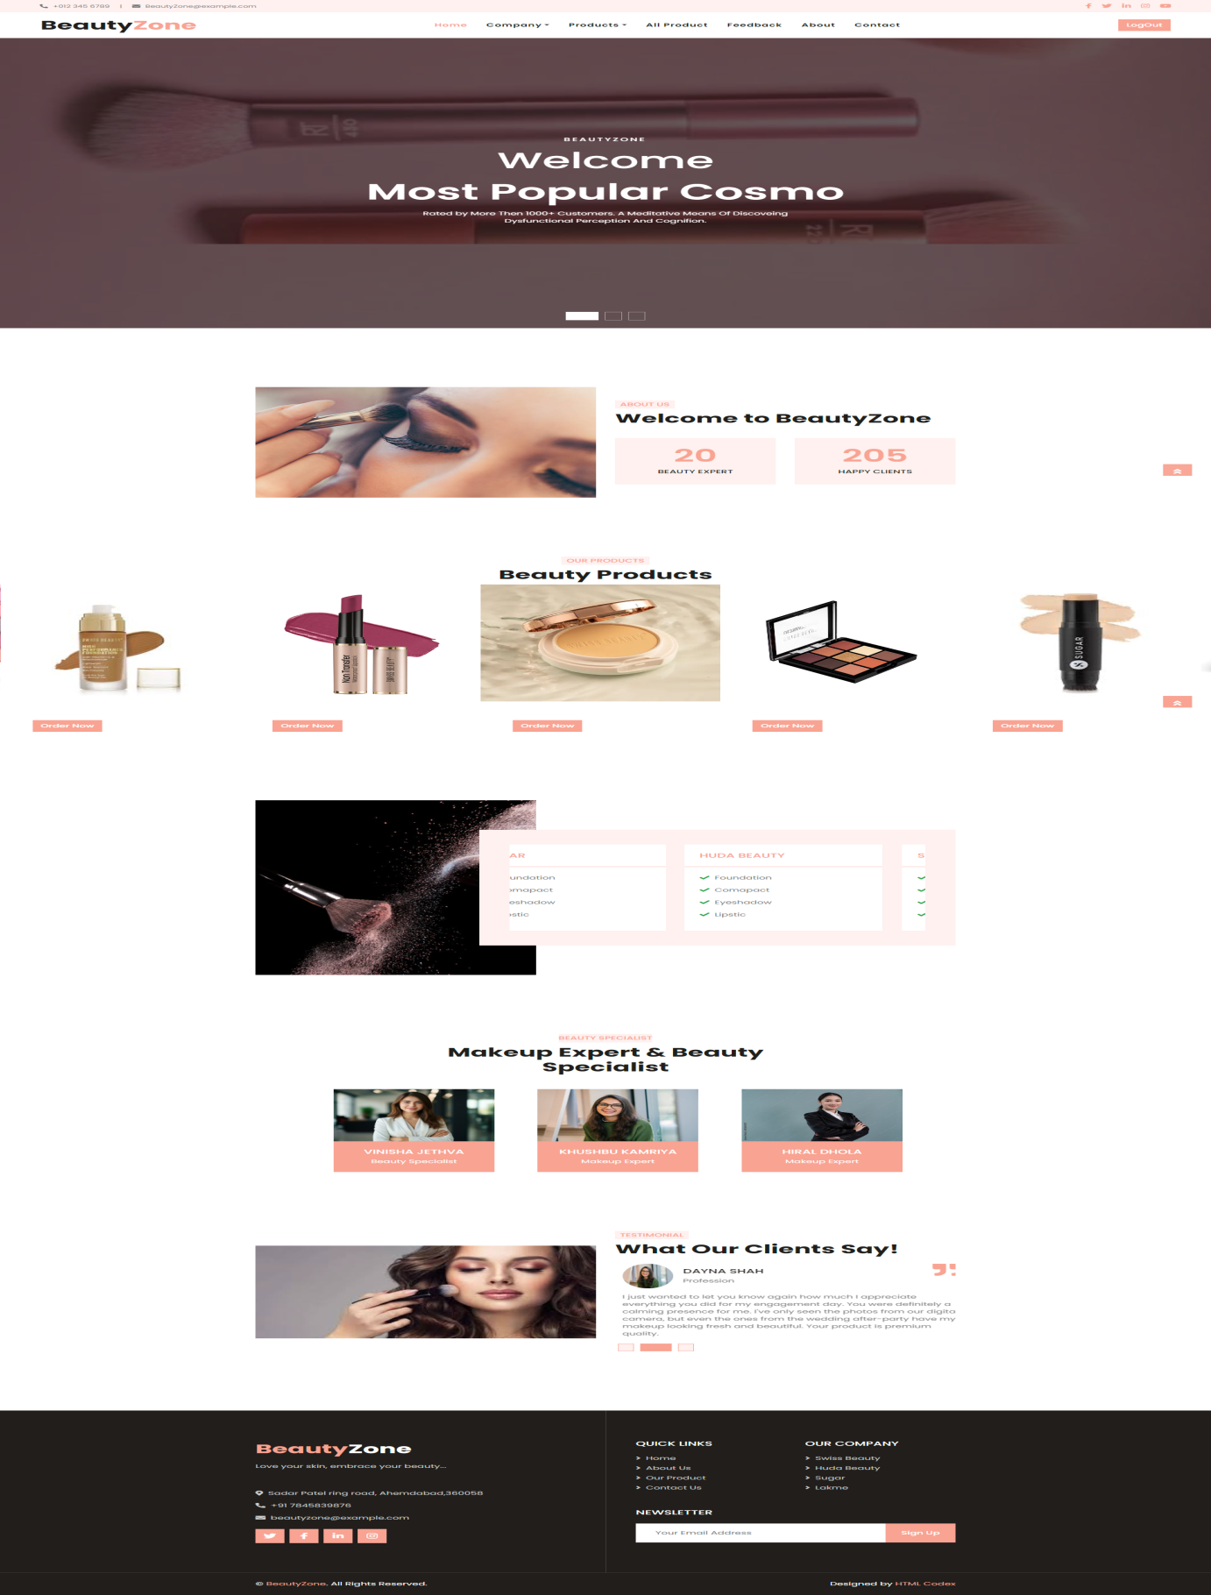

**Coding:-index.php**

<?php include("header1.php"); ?>

<!-- Carousel Start -->

<div class="container-fluid p-0 mb-5 pb-5">

<div id="header-carousel" class="carousel slide carousel-fade" data-ride="carousel">

<ol class="carousel-indicators">

<li data-target="#header-carousel" data-slide-to="0" class="active"></li>

<li data-target="#header-carousel" data-slide-to="1"></li>

<li data-target="#header-carousel" data-slide-to="2"></li>

</ol>

<div class="carousel-inner">

<div class="carousel-item position-relative active" style="min-height: 100vh;">

<img class="position-absolute w-100 h-100" src="image_project/giphy.webp" style="object-fit: cover;">

<div class="carousel-caption d-flex flex-column align-items-center justify-content-center">

<div class="p-3" style="max-width: 900px;">

<h6 class="text-white text-uppercase mb-3 animate__animated animate__fadeInDown" style="letter-spacing: 3px;">BeautyZone</h6>

<h5 class="display-3 text-capitalize text-white mb-3">Welcome</h5>

<h3 class="display-3 text-capitalize text-white mb-3">Most Popular

Cosmo</h3>

<p class="mx-md-5 px-5">Rated by More Then 1000+ Customers. A Meditative

Means Of Discoveing Dysfunctional Perception And Cognifion.</p>

</div>

</div>

</div>

<div class="carousel-item position-relative" style="min-height: 100vh;">

<img class="position-absolute w-100 h-100" src="image_project/bgnew2.gif" style="object-fit: cover;">

<div class="carousel-caption d-flex flex-column align-items-center justify-content-center">

<div class="p-3" style="max-width: 900px;">

<h6 class="text-white text-uppercase mb-3 animate__animated animate__fadeInDown" style="letter-spacing: 3px;">BeautyZone</h6>

<h3 class="display-3 text-capitalize text-white mb-3">Premium Beauty

Products</h3>

<p class="mx-md-5 px-5">Rated by More Then 1000+ Customers. A Meditative

Means Of Discoveing Dysfunctional Perception And Cognifion.</p>

</div>

</div>

</div>

<div class="carousel-item position-relative" style="min-height: 100vh;">

<img class="position-absolute w-100 h-100" src="image_project/bgnew1.webp" style="object-fit: cover;">

<div class="carousel-caption d-flex flex-column align-items-center justify-content-center">

<div class="p-3" style="max-width: 900px;">

<h6 class="text-white text-uppercase mb-3 animate__animated animate__fadeInDown" style="letter-spacing: 3px;">BeautyZone</h6>

<h3 class="display-3 text-capitalize text-white mb-3">Make Your Skin

Shine & Glowing</h3>

<p class="mx-md-5 px-5">Rated by More Then 1000+ Customers. A Meditative

Means Of Discoveing Dysfunctional Perception And Cognifion.</p>

</div>

</div>

</div>

</div>

</div>

</div>

<!-- Carousel End -->

<!-- About Start -->

<div class="container-fluid py-5">

<div class="container py-5">

<div class="row align-items-center">

<div class="col-lg-6 pb-5 pb-lg-0">

<img class="img-fluid w-100" src="../Client/image_project/model.jpg" alt="">

</div>

<div class="col-lg-6">

<h6 class="d-inline-block text-primary text-uppercase bg-light py-1 px-2">About

Us</h6>

<h1 class="mb-4">Welcome to BeautyZone </h1>

<p class="pl-4 border-left border-primary"></p>

<div class="row pt-3">

<div class="col-6">

<div class="bg-light text-center p-4">

<h3 class="display-4 text-primary" data-toggle="counter-up">99</h3>

<h6 class="text-uppercase">Beauty Expert</h6>

<h6 class="text-uppercase"></h6>

</div>

</div>

<div class="col-6">

<div class="bg-light text-center p-4">

<h3 class="display-4 text-primary" data-toggle="counter-up">999</h3>

<h6 class="text-uppercase">Happy Clients</h6>

</div>

</div>

</div>

</div>

</div>

</div>

</div>

<!-- About End -->

<!-- Service Start -->

<div class="container-fluid px-0 py-5 my-5">

<div class="row mx-0 justify-content-center text-center">

<div class="col-lg-6">

<h6 class="d-inline-block bg-light text-primary text-uppercase py-1 px-2">Our

Products</h6>

<h1> Beauty Products</h1>

</div>

</div>

<div class="owl-carousel service-carousel">

<div class="Products-item position-relative">

<img class="img-fluid" src="../Client/image_project/fouswiss1.jpg" alt="">

<div class="service-text text-center">

<h4 class="text-white font-weight-medium px-3">Foundation</h4>

<div class="w-100 bg-white text-center p-4" >

<a class="btn btn-primary" href="Foundation.php">Order Now</a>

</div>

</div>

</div>

<div class="Products-item position-relative">

<img class="img-fluid" src="../Client/image_project/lipswiss4.webp" alt="">

<div class="service-text text-center">

<h4 class="text-white font-weight-medium px-3">Lipstick</h4>

<div class="w-100 bg-white text-center p-4" >

<a class="btn btn-primary" href="Lipstick.php">Order Now</a>

</div>

</div>

</div>

<div class="Products-item position-relative">

<img class="img-fluid" src="../Client/image_project/compswiss2.webp" alt="">

<div class="service-text text-center">

<h4 class="text-white font-weight-medium px-3">Compect</h4>

<div class="w-100 bg-white text-center p-4" >

<a class="btn btn-primary" href="Compect.php">Order Now</a>

</div>

</div>

</div>

<div class="Products-item position-relative">

<img class="img-fluid" src="../Client/image_project/Eyeshadowswiss.jpg" alt="">

<div class="service-text text-center">

<h4 class="text-white font-weight-medium px-3">Eyeshadow</h4>

<div class="w-100 bg-white text-center p-4" >

<a class="btn btn-primary" href="Eyeshadow.php">Order Now</a>

</div>

</div>

</div>

<div class="Products-item position-relative">

<img class="img-fluid" src="../Client/image_project/fousugar.jpg" alt="">

<div class="service-text text-center">

<h4 class="text-white font-weight-medium px-3">Foundation</h4>

<div class="w-100 bg-white text-center p-4" >

<a class="btn btn-primary" href="Foundation.php">Order Now</a>

</div>

</div>

</div>

<div class="Products-item position-relative">

<img class="img-fluid" src="../Client/image_project/compsugar3.jpg" alt="">

<div class="service-text text-center">

<h4 class="text-white font-weight-medium px-3">Compect</h4>

<div class="w-100 bg-white text-center p-4" >

<a class="btn btn-primary" href="Compect.php">Order Now</a>

</div>

</div>

</div>

<div class="Products-item position-relative">

<img class="img-fluid" src="../Client/image_project/Eyeshadowsugar2.jpg" alt="">

<div class="service-text text-center">

<h4 class="text-white font-weight-medium px-3">Eyeshadow</h4>

<div class="w-100 bg-white text-center p-4" >

<a class="btn btn-primary" href="Eyeshadow.php">Order Now</a>

</div>

</div>

</div>

<div class="Products-item position-relative">

<img class="img-fluid" src="../Client/image_project/Eyeshadowhuda1.jpg" alt="">

<div class="service-text text-center">

<h4 class="text-white font-weight-medium px-3">Eyeshadow</h4>

<div class="w-100 bg-white text-center p-4" >

<a class="btn btn-primary" href="Eyeshadow.php">Order Now</a>

</div>

</div>

</div>

<div class="Products-item position-relative">

<img class="img-fluid" src="../Client/image_project/foulakme1.webp" alt="">

<div class="service-text text-center">

<h4 class="text-white font-weight-medium px-3">Foundation</h4>

<div class="w-100 bg-white text-center p-4" >

<a class="btn btn-primary" href="Foundation.php">Order Now</a>

</div>

</div>

</div>

<div class="Products-item position-relative">

<img class="img-fluid" src="../Client/image_project/complakme1.webp" alt="">

<div class="service-text text-center">

<h4 class="text-white font-weight-medium px-3">Compect</h4>

<div class="w-100 bg-white text-center p-4" >

<a class="btn btn-primary" href="Compect.php">Order Now</a>

</div>

</div>

</div>

<div class="Products-item position-relative">

<img class="img-fluid" src="../Client/image_project/Eyeshadowlakme3.webp"

alt="">

<div class="service-text text-center">

<h4 class="text-white font-weight-medium px-3">Eyeshadow</h4>

<div class="w-100 bg-white text-center p-4" >

<a class="btn btn-primary" href="Eyeshadow.php">Order Now</a>

</div>

</div>

</div>

</div>

</form>

</div>

</div>

</div>

</div>

<!-- Service End -->

<!-- Open Hours Start -->

<!--<div class="container-fluid py-5">

<div class="container py-5">

<div class="row">

<div class="col-lg-6" style="min-height: 500px;">

<div class="position-relative h-100"><img class="position-absolute w-100 h-100" src="../Client/image_project/brushlakme3.jpg" style="object-fit: cover;">

</div>

</div>

<div class="col-lg-6 pt-5 pb-lg-5">

<div class="hours-text bg-light p-4 p-lg-5 my-lg-5">

<h6 class="d-inline-block text-white text-uppercase bg-primary py-1 px-2">Open Hours</h6>

<h1 class="mb-4">Best Beauty Products</h1>

<p>Dolores lorem lorem ipsum sit et ipsum. Sadip sea amet diam dolore sed et. Sit rebum labore sit sit ut vero no sit. Et elitr stet dolor sed sit et sed ipsum et kasd ut. Erat duo eos et erat sed diam duo</p>

<ul class="list-inline">

<li class="h6 py-1"><i class="far fa-circle text-primary mr-3"></i>Mon ? Fri : 9:00 AM - 7:00 PM</li>

<li class="h6 py-1"><i class="far fa-circle text-primary mr-3"></i>Saturday : 9:00 AM - 6:00 PM</li>

<li class="h6 py-1"><i class="far fa-circle text-primary mr-3"></i>Sunday : Closed</li>

</ul>

<a href="" class="btn btn-primary mt-2">Book Now</a>

</div>

</div>

</div>

</div>

</div>-->

<!-- Open Hours End -->

<!<!-- Pricing Start -->

<div class="container-fluid py-5">

<div class="container py-5">

<div class="row">

<div class="col-lg-5" style="min-height: 500px;">

<div class="position-relative h-100"><img class="position-absolute w-100 h-100"src="image_project/bg10" style="object-fit: cover;">

</div>

</div>

<div class="col-lg-7 pt-5 pb-lg-5">

<div class="pricing-text bg-light p-4 p-lg-5 my-lg-5">

<div class="owl-carousel pricing-carousel">

<div class="bg-white">

<div class="d-flex align-items-center justify-content-between border-bottom border-primary p-4">

<h5 class="text-primary text-uppercase m-0" >Sugar</h5>

</div>

<div class="p-4">

<p><i class="fa fa-check text-success mr-2"></i>Foundation</p>

<p><i class="fa fa-check text-success mr-2"></i>Comapact</p>

<p><i class="fa fa-check text-success mr-2"></i>Eyeshadow</p>

<p><i class="fa fa-check text-success mr-2"></i>Lipstic</p>

</div>

</div>

<div class="bg-white">

<div class="d-flex align-items-center justify-content-between border-bottom border-primary p-4">

<h5 class="text-primary text-uppercase m-0">HUDA Beauty</h5>

</div>

<div class="p-4">

<p><i class="fa fa-check text-success mr-2"></i>Foundation</p>

<p><i class="fa fa-check text-success mr-2"></i>Comapact</p>

<p><i class="fa fa-check text-success mr-2"></i>Eyeshadow</p>

<p><i class="fa fa-check text-success mr-2"></i>Lipstic</p>

</div>

</div>

<div class="bg-white">

<div class="d-flex align-items-center justify-content-between border-bottom border-primary p-4">

<h5 class="text-primary text-uppercase m-0">Swiss Beauty</h5>

</div>

<div class="p-4">

<p><i class="fa fa-check text-success mr-2"></i>Foundation</p>

<p><i class="fa fa-check text-success mr-2"></i>Comapact</p>

<p><i class="fa fa-check text-success mr-2"></i>Eyeshadow</p>

<p><i class="fa fa-check text-success mr-2"></i>Lipstic</p>

</div>

</div>

<div class="bg-white">

<div class="d-flex align-items-center justify-content-between border-bottom border-primary p-4">

<h5 class="text-primary text-uppercase m-0">Lakme</h5>

</div>

<div class="p-4">

<p><i class="fa fa-check text-success mr-2"></i>Foundation</p>

<p><i class="fa fa-check text-success mr-2"></i>Comapact</p>

<p><i class="fa fa-check text-success mr-2"></i>Eyeshadow</p>

<p><i class="fa fa-check text-success mr-2"></i>Lipstic</p>

</div>

</div>

</div>

</div>

</div>

</div>

</div>

</div>

<!-- Pricing End -->

<!-- Team Start -->

<div class="container-fluid py-5">

<div class="container pt-5">

<div class="row justify-content-center text-center">

<div class="col-lg-6">

<h6 class="d-inline-block bg-light text-primary text-uppercase py-1 px-2s">Beauty

Specialist</h6>

<h1 class="mb-5">Makeup Expert & Beauty Specialist</h1>

</div>

</div>

<div class="row">

&nbsp;&nbsp;&nbsp;&nbsp;&nbsp;&nbsp;&nbsp;&nbsp;&nbs;&nbsp;&nbsp;

&nbsp;&nbsp;&nbsp;&nbsp;

<div class="col-lg-3 col-md-6">

<div class="team position-relative overflow-hidden mb-5">

<img class="img-fluid" src="image_project/modelv.jpg" alt="">

<div class="position-relative text-center">

<div class="team-text bg-primary text-white">

<h5 class="text-white text-uppercase">Vinisha Jethva</h5>

<p class="m-0"> Beauty Specialist</p>

</div>

<div class="team-social bg-dark text-center">

<a class="btn btn-outline-primary btn-square mr-2" href="#"><i class="fab fa-twitter"></i></a>

<a class="btn btn-outline-primary btn-square mr-2" href="#"><i class="fab fa-facebook-f"></i></a>

<a class="btn btn-outline-primary btn-square mr-2" href="#"><i class="fab fa-linkedin-in"></i></a>

<a class="btn btn-outline-primary btn-square" href="#"><i class="fab fa-instagram"></i></a>

</div>

</div>

</div>

</div>

&nbsp;&nbsp;&nbsp;&nbsp;&nbsp;

<div class="col-lg-3 col-md-6">

<div class="team position-relative overflow-hidden mb-5">

<img class="img-fluid" src="image_project/feedback2.jpg" alt="">

<div class="position-relative text-center">

<div class="team-text bg-primary text-white">

<h5 class="text-white text-uppercase">Khushbu Kamriya</h5>

<p class="m-0">Makeup Expert</p>

</div>

<div class="team-social bg-dark text-center">

<a class="btn btn-outline-primary btn-square mr-2" href="#"><i class="fab fa-twitter"></i></a>

<a class="btn btn-outline-primary btn-square mr-2" href="#"><i class="fab fa-facebook-f"></i></a>

<a class="btn btn-outline-primary btn-square mr-2" href="#"><i class="fab fa-linkedin-in"></i></a>

<a class="btn btn-outline-primary btn-square" href="#"><i class="fab fa-instagram"></i></a>

</div>

</div>

</div>

</div>

&nbsp;

&nbsp;

&nbsp;

&nbsp;

&nbsp;

<div class="col-lg-3 col-md-6">

<div class="team position-relative overflow-hidden mb-5">

<img class="img-fluid" src="image_project/MODELL.jpg" alt="">

<div class="position-relative text-center">

<div class="team-text bg-primary text-white">

<h5 class="text-white text-uppercase">Hiral Dhola</h5>

<p class="m-0">Makeup Expert</p>

</div>

<div class="team-social bg-dark text-center">

<a class="btn btn-outline-primary btn-square mr-2" href="#"><i class="fab fa-twitter"></i></a>

<a class="btn btn-outline-primary btn-square mr-2" href="#"><i class="fab fa-facebook-f"></i></a>

<a class="btn btn-outline-primary btn-square mr-2" href="#"><i class="fab fa-linkedin-in"></i></a>

<a class="btn btn-outline-primary btn-square" href="#"><i class="fab fa-instagram"></i></a>

</div>

</div>

</div>

</div>

</div>

</div>

</div>

<!-- Team End -->

<!-- Testimonial Start -->

<div class="container-fluid py-5">

<div class="container py-5">

<div class="row align-items-center">

<div class="col-lg-6 pb-5 pb-lg-0">

<img class="img-fluid w-100" src="image_project/bg9.jpg" alt="">

</div>

<div class="col-lg-6">

<h6 class="d-inline-block text-primary text-uppercase bg-light py-1 px-2">Testimonial</h6>

<h1 class="mb-4">What Our Clients Say!</h1>

<div class="owl-carousel testimonial-carousel">

<div class="position-relative"><i class="fa fa-3x fa-quote-right text-primary position-absolute" style="top: -6px; right: 0;"></i>

<div class="d-flex align-items-center mb-3"><img class="img-fluid rounded-circle" src="image_project/feedback1.jpg" style="width: 80px; height: 80px;" alt="">

<div class="ml-3">

<h5 class="text-uppercase">Saru oberoi</h5>

<span>Profession</span></div>

</div>

<p class="m-0">Just wanted to say thanks for doing such a great job

with makeup for my wedding. I have never felt so beautiful in my

life (at age 31!) and the pictures look fabulous. You were great

to work with! I just wanted to say thank you again for everything.</p>

</div>

<div class="position-relative"><i class="fa fa-3x fa-quote-right text-primary position-absolute" style="top: -6px; right: 0;"></i>

<div class="d-flex align-items-center mb-3"><img class="img-fluid rounded-circle" src="image_project/feedback2.jpg" style="width: 80px; height: 80px;" alt="">

<div class="ml-3">

<h5 class="text-uppercase">Dayna shah</h5>

<span>Profession</span></div>

</div>

<p class="m-0">I just wanted to let you know again how much I appreciate

everything you did for my engagement day. You were definitely a

calming presence for me. I've only seen the photos from our digital

camera, but even the ones from the wedding after-party have my makeup

looking fresh and beautiful. Your product is premium quality.</p>

</div>

<div class="position-relative"><i class="fa fa-3x fa-quote-right text-primary position-absolute" style="top: -6px; right: 0;"></i>

<div class="d-flex align-items-center mb-3"><img class="img-fluid rounded-circle" src="image_project/feedback3.jpg" style="width: 80px; height: 80px;" alt="">

<div class="ml-3">

<h5 class="text-uppercase">Jenna ortega</h5>

<span>Profession</span></div>

</div>

<p class="m-0">my skin is so sensitive so i can,t do makup ,but i

try your website's product and i use on my skin,oh my god my skin

was absolutely fine and i looking so beautiful.thank you so mach

for this product </p>

</div></div></div></div></div></div>

<!-- Testimonial End -->

<?php include("footer1.php"); ?>

**Form :-product.php**

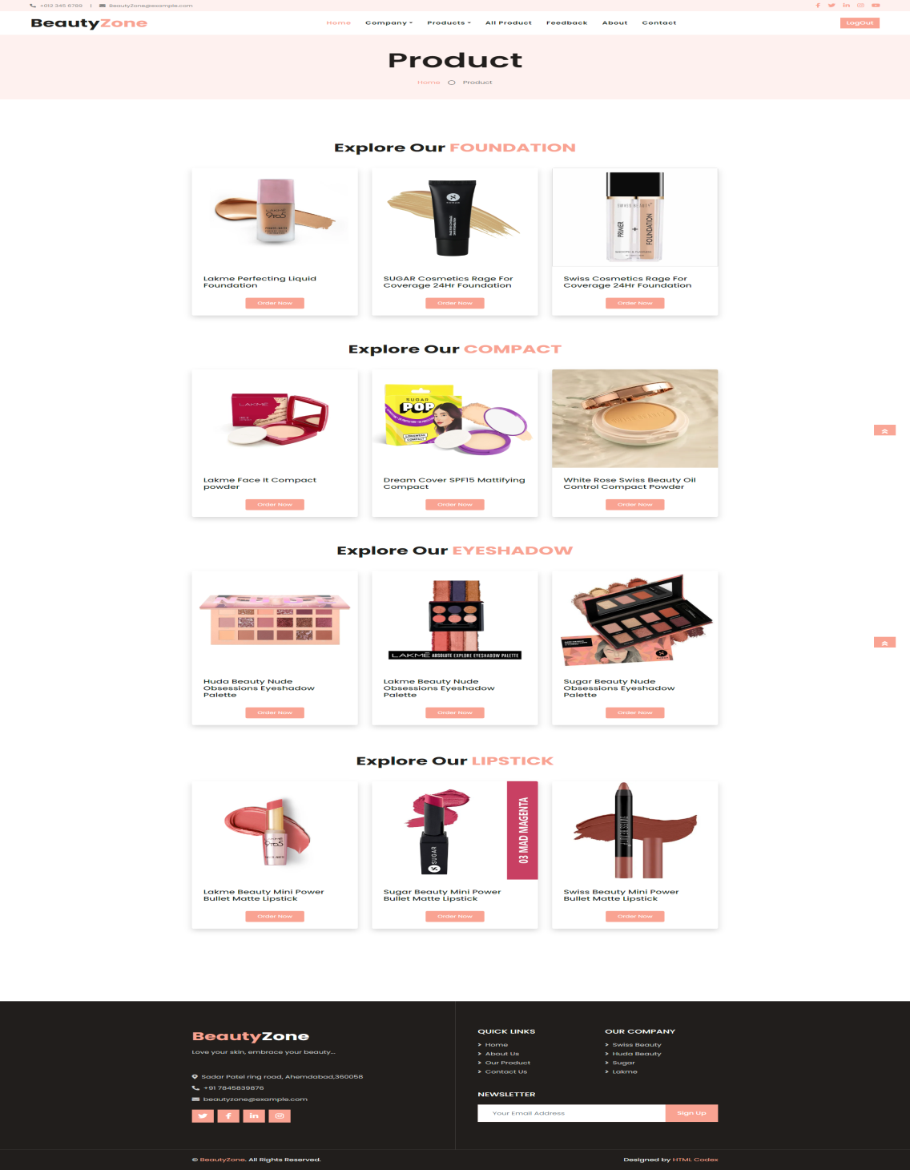

**Coding:-product.php**

<?php include("header1.php"); ?>

<!-- Page Header Start -->

<!-- Header Start -->

<div class="bg-light" style="margin-bottom: 100px;">

<div class="container text-center py-5">

<h3 class="text-black display-3 mb-4">Product</h3>

<div class="d-inline-flex align-items-center text-black">

<p class="m-0"><a class="text-black" href="">Home</a></p>

<i class="far fa-circle px-3"></i>

<p class="m-0">Product</p>

</div>

</div>

</div>

<!-- Header End -->

<!-- Page Header End -->

<!-- products Start -->

<!-- Foundation start -->

<div class="container-xxl py-5">

<div class="container">

<div class="text-center wow fadeInUp" data-wow-delay="0.1s">

<h1 class="mb-5">Explore Our <span class="text-primary text-uppercase">Foundation</span></h1>

</div>

<div class="row g-4" >

<div class="col-lg-4 col-md-6 wow fadeInUp" data-wow-delay="0.1s">

<div class="room-item shadow rounded overflow-hidden" >

<div class="position-relative" ><img class="img-fluid" src="image_project/foulakme1.webp" alt="">

<small class="position-absolute start-0 top-100 translate-middle-y bg-primary text-white rounded py-1 px-3 ms-4">$100/Night</small>

</div>

<div class="p-4 mt-2">

<div class="d-flex justify-content-between mb-3">

<h5 class="mb-0">Lakme Perfecting Liquid Foundation</h5>

</div>

<div class="d-flex mb-3">

<!--<small class="border-end me-3 pe-3"><i class="fa fa-bed text-primary me-2"></i>3 Bed</small>

<small class="border-end me-3 pe-3"><i class="fa fa-bath text-primary me-2"></i>2 Bath</small>

<small><i class="fa fa-wifi text-primary me-2"></i>Wifi</small>-->

</div>

<!--<p class="text-body mb-3">Erat ipsum justo amet duo et elitr dolor, est duo duo eos lorem sed diam stet diam sed stet lorem.</p>-->

<div align="center">

<a class="btn btn-sm btn-primary rounded py-2 px-4" href="Foundation.php">Order Now</a>

</div>

</div>

</div>

</div>

<div class="col-lg-4 col-md-6 wow fadeInUp" data-wow-delay="0.3s">

<div class="room-item shadow rounded overflow-hidden">

<div class="position-relative"><img class="img-fluid" src="image_project/fousugar2.jpg" alt="">

<small class="position-absolute start-0 top-100 translate-middle-y bg-primary text-white rounded py-1 px-3 ms-4">$100/Night</small>

</div>

<div class="p-4 mt-2">

<div class="d-flex justify-content-between mb-3">

<h5 class="mb-0">SUGAR Cosmetics Rage For Coverage 24Hr Foundation </h5>

</div>

<div class="d-flex mb-3">

<!--<small class="border-end me-3 pe-3"><i class="fa fa-bed text-primary me-2"></i>3 Bed</small>

<small class="border-end me-3 pe-3"><i class="fa fa-bath text-primary me-2"></i>2 Bath</small>

<small><i class="fa fa-wifi text-primary me-2"></i>Wifi</small>-->

</div>

<!--<p class="text-body mb-3">Erat ipsum justo amet duo et elitr dolor, est duo duo eos lorem sed diam stet diam sed stet lorem.</p>-->

<div align="center">

<a class="btn btn-sm btn-primary rounded py-2 px-4" href="Foundation.php">Order Now</a>

</div>

</div>

</div>

</div>

<div class="col-lg-4 col-md-6 wow fadeInUp" data-wow-delay="0.6s">

<div class="room-item shadow rounded overflow-hidden">

<div class="position-relative">

<img class="img-fluid" src="image_project/fouswiss1.webp" alt="">

<small class="position-absolute start-0 top-100 translate-middle-y bg-primary text-white rounded py-1 px-3 ms-4">$100/Night</small>

</div>

<div class="p-4 mt-2">

<div class="d-flex justify-content-between mb-3">

<h5 class="mb-0">Swiss Cosmetics Rage For Coverage 24Hr Foundation </h5>

</div>

<div class="d-flex mb-3">

<!--<small class="border-end me-3 pe-3"><i class="fa fa-bed text-primary me-2"></i>3 Bed</small>

<small class="border-end me-3 pe-3"><i class="fa fa-bath text-primary me-2"></i>2 Bath</small>

<small><i class="fa fa-wifi text-primary me-2"></i>Wifi</small>-->

</div>

<!--<p class="text-body mb-3">Erat ipsum justo amet duo et elitr dolor, est duo duo eos lorem sed diam stet diam sed stet lorem.</p>-->

<div align="center">

<a class="btn btn-sm btn-primary rounded py-2 px-4" href="Foundation.php">Order Now</a>

</div>

</div>

</div>

</div>

</div>

</div>

</div>

<!-- Foundation End-->

<!-- Compact start -->

<div class="container-xxl py-5">

<div class="container">

<div class="text-center wow fadeInUp" data-wow-delay="0.1s">

<h1 class="mb-5">Explore Our <span class="text-primary text-uppercase">Compact</span></h1>

</div>

<div class="row g-4" >

<div class="col-lg-4 col-md-6 wow fadeInUp" data-wow-delay="0.1s">

<div class="room-item shadow rounded overflow-hidden" >

<div class="position-relative" ><img class="img-fluid" src="image_project/complakme1.webp"alt="">

<small class="position-absolute start-0 top-100 translate-middle-y bg-primary text-white rounded py-1 px-3 ms-4">$100/Night</small>

</div>

<div class="p-4 mt-2">

<div class="d-flex justify-content-between mb-3">

<h5 class="mb-0">Lakme Face It Compact powder</h5>

</div>

<div class="d-flex mb-3">

</div>

<div align="center">

<a class="btn btn-sm btn-primary rounded py-2 px-4" href="Compact.php">Order Now</a>

</div>

</div>

</div>

</div>

<div class="col-lg-4 col-md-6 wow fadeInUp" data-wow-delay="0.3s">

<div class="room-item shadow rounded overflow-hidden">

<div class="position-relative"><img class="img-fluid" src="image_project/compsugar3.jpg" alt="">

<small class="position-absolute start-0 top-100 translate-middle-y bg-primary text-white rounded py-1 px-3 ms-4">$100/Night</small>

</div>

<div class="p-4 mt-2">

<div class="d-flex justify-content-between mb-3">

<h5 class="mb-0">Dream Cover SPF15 Mattifying Compact</h5>

</div>

<div class="d-flex mb-3">

</div>

<div align="center">

<a class="btn btn-sm btn-primary rounded py-2 px-4" href="Compact.php">Order Now</a>

</div>

</div>

</div>

</div>

<div class="col-lg-4 col-md-6 wow fadeInUp" data-wow-delay="0.6s">

<div class="room-item shadow rounded overflow-hidden">

<div class="position-relative">

<img class="img-fluid" src="image_project/compswiss2.webp" alt="">

<small class="position-absolute start-0 top-100 translate-middle-y bg-primary text-white rounded py-1 px-3 ms-4">$100/Night</small>

</div>

<div class="p-4 mt-2">

<div class="d-flex justify-content-between mb-3">

<h5 class="mb-0">White Rose Swiss Beauty Oil Control Compact Powder</h5>

</div>

<div class="d-flex mb-3">

</div>

<div align="center">

<a class="btn btn-sm btn-primary rounded py-2 px-4" href="Compact.php">Order Now</a>

</div>

</div>

</div>

</div>

</div>

</div>

</div>

<!-- Compact End -->

<!-- Eyeshadow start -->

<div class="container-xxl py-5">

<div class="container">

<div class="text-center wow fadeInUp" data-wow-delay="0.1s">

<h1 class="mb-5">Explore Our <span class="text-primary text-uppercase">Eyeshadow</span></h1>

</div>

<div class="row g-4" >

<div class="col-lg-4 col-md-6 wow fadeInUp" data-wow-delay="0.1s">

<div class="room-item shadow rounded overflow-hidden" >

<div class="position-relative" >

<img class="img-fluid" src="image_project/Eyeshadowhuda1.jpg" alt="">

<small class="position-absolute start-0 top-100 translate-middle-y bg-primary text-white rounded py-1 px-3 ms-4">$100/Night</small>

</div>

<div class="p-4 mt-2">

<div class="d-flex justify-content-between mb-3">

<h5 class="mb-0">Huda Beauty Nude Obsessions Eyeshadow Palette</h5>

</div>

<div class="d-flex mb-3">

</div>

<div align="center">

<a class="btn btn-sm btn-primary rounded py-2 px-4" href="Eyeshadow.php">Order Now</a>

</div>

</div>

</div>

</div>

<div class="col-lg-4 col-md-6 wow fadeInUp" data-wow-delay="0.3s">

<div class="room-item shadow rounded overflow-hidden">

<div class="position-relative"><img class="img-fluid" src="image_project/Eyeshadowlakme4.webp" alt="">

</div>

<div class="p-4 mt-2">

<div class="d-flex justify-content-between mb-3">

<h5 class="mb-0">Lakme Beauty Nude Obsessions Eyeshadow Palette</h>

</div>

<div class="d-flex mb-3">

</div>

<div align="center">

<a class="btn btn-sm btn-primary rounded py-2 px-4" href="Eyeshadow.php">Order Now</a>

</div>

</div>

</div>

</div>

<div class="col-lg-4 col-md-6 wow fadeInUp" data-wow-delay="0.6s">

<div class="room-item shadow rounded overflow-hidden">

<div class="position-relative"><img class="img-fluid" src="image_project/Eyeshadowsugar3.webp" alt="">

<small class="position-absolute start-0 top-100 translate-middle-y bg-primary text-white rounded py-1 px-3 ms-4">$100/Night</small>

</div>

<div class="p-4 mt-2">

<div class="d-flex justify-content-between mb-3">

<h5 class="mb-0">Sugar Beauty Nude Obsessions Eyeshadow Palette</h5>

</div>

<div class="d-flex mb-3">

</div>

<div align="center">

<a class="btn btn-sm btn-primary rounded py-2 px-4" href="Eyeshadow.php">Order Now</a>

</div>

</div>

</div>

</div>

</div>

</div>

</div>

<!-- Eyeshadow End -->

<!-- lipstick start -->

<div class="container-xxl py-5">

<div class="container">

<div class="text-center wow fadeInUp" data-wow-delay="0.1s">

<h6 class="section-title text-center text-primary text-uppercase"></h6>

<h1 class="mb-5">Explore Our <span class="text-primary text-uppercase">Lipstick</span></h1>

</div>

<div class="row g-4" >

<div class="col-lg-4 col-md-6 wow fadeInUp" data-wow-delay="0.1s">

<div class="room-item shadow rounded overflow-hidden" >

<div class="position-relative" >

<img class="img-fluid" src="image_project/liplakme3.webp" alt="">

<small class="position-absolute start-0 top-100 translate-middle-y bg-primary text-white rounded py-1 px-3 ms-4">$100/Night</small>

</div>

<div class="p-4 mt-2">

<div class="d-flex justify-content-between mb-3">

<h5 class="mb-0">Lakme Beauty Mini Power Bullet Matte Lipstick</h5>

</div>

<div class="d-flex mb-3">

</div>

<div align="center">

<a class="btn btn-sm btn-primary rounded py-2 px-4" href="Lipstick.php">Order Now</a>

</div>

</div>

</div>

</div>

<div class="col-lg-4 col-md-6 wow fadeInUp" data-wow-delay="0.3s">

<div class="room-item shadow rounded overflow-hidden">

<div class="position-relative">

<img class="img-fluid" src="image_project/lipsugar1.jpg"alt="">

<small class="position-absolute start-0 top-100 translate-middle-y bg-primary text-white rounded py-1 px-3 ms-4">$100/Night</small>

</div>

<div class="p-4 mt-2">

<div class="d-flex justify-content-between mb-3">

<h5 class="mb-0">Sugar Beauty Mini Power Bullet Matte Lipstick</h5>

</div>

<div class="d-flex mb-3">

</div>

<div align="center">

<a class="btn btn-sm btn-primary rounded py-2 px-4" href="Lipstick.php">Order Now</a>

</div>

</div>

</div>

</div>

<div class="col-lg-4 col-md-6 wow fadeInUp" data-wow-delay="0.6s">

<div class="room-item shadow rounded overflow-hidden">

<div class="position-relative">

<img class="img-fluid" src="image_project/lipswiss3.webp" alt="">

<small class="position-absolute start-0 top-100 translate-middle-y bg-primary text-white rounded py-1 px-3 ms-4">$100/Night</small>

</div>

<div class="p-4 mt-2">

<div class="d-flex justify-content-between mb-3">

<h5 class="mb-0">Swiss Beauty Mini Power Bullet Matte Lipstick</h5>

</div>

<div class="d-flex mb-3">

</div>

<div align="center">

<a class="btn btn-sm btn-primary rounded py-2 px-4" href="Lipstick.php">Order Now</a>

</div>

</div>

</div>

</div>

</div>

</div>

</div>

<!-- lipstick End -->

<!-- products End -->

<br><br><br><br><br>

<?php include("footer1.php"); ?>

**Form :- foundation.php**

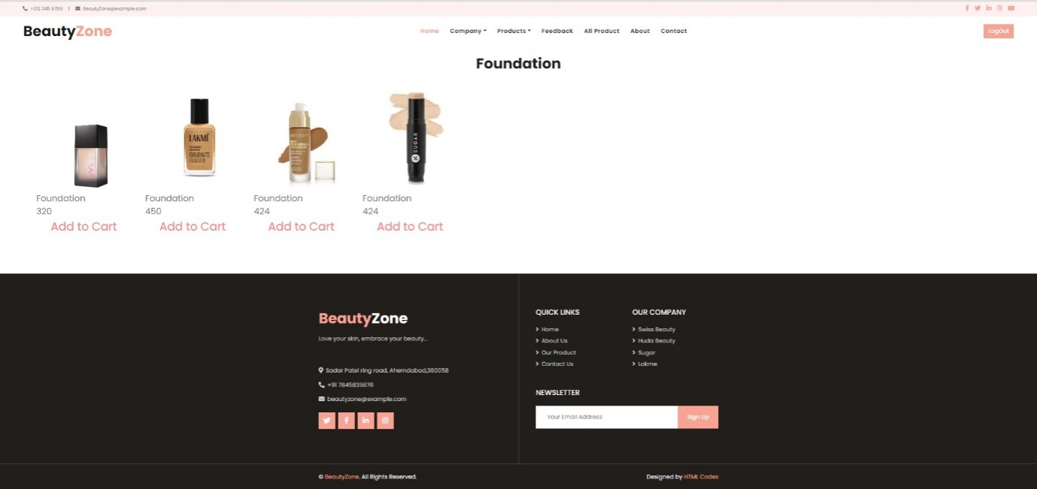

**Coding:-foundation.php**

<?php

include("header1.php")

?>

<!-- items -->

<br>

<?php

include("con1.php");

$query="select *from items where itemname='Foundation'";

$result=mysqli_query($con,$query);

echo"<table align='center' style='margin-left:100px'>

<h1 align='center'>Foundation</h1>";

while($row=mysqli_fetch_array($result))

{

echo "<td>";

echo " <img src='image_project/$row[4]' height=300 width=300 >";

echo "<br>";

echo "<font size='+2'>";

echo $row["itemname"];

echo "<br>";

echo $row["price"];

echo "<br>";

echo "</font>";

echo "<a hre='addtocart.php?id=".$row[0]."'><font color='#FF8080' size='+3'><ul>Add to Cart</ul></font></a>";

echo "</td>";

}

echo"</tr>";

echo"<br>";

echo"</table>";

?>

<?php

include("footer1.php")

?>

**Form :- lipstick.php**

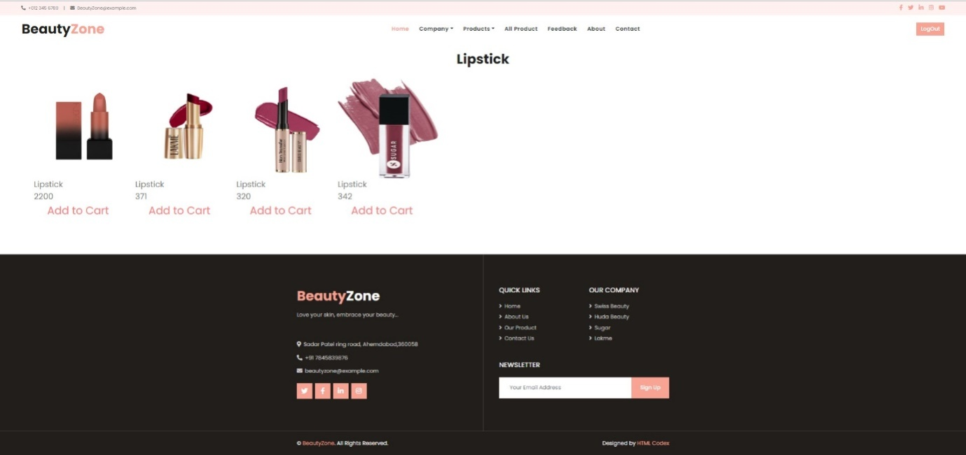

**Coding:-lipstick.php**

<?php

include("header1.php")

?>

<!-- items -->

<br>

<?php

include("con1.php");

$query="select *from items where itemname='Lipstick'";

$result=mysqli_query($con,$query);

echo"<table align='center' style='margin-left:100px'>

<h1 align='center'>Lipstick</h1>";

while($row=mysqli_fetch_array($result))

{

echo "<td>";

echo " <img src='image_project/$row[4]' height=300 width=300 >";

echo "<br>";

echo "<font size='+2'>";

echo $row["itemname"];

echo "<br>";

echo $row["price"];

echo "<br>";

echo "</font>";

echo "<a href='addtocart.php?id=".$row[0]."'><font color='#FF8080' size='+3'><ul>Add to Cart</ul></font></a>";

echo "</td>";

}

echo"</tr>";

echo"<br>";

echo"</table>";

?>

<?php

include("footer1.php")

?>

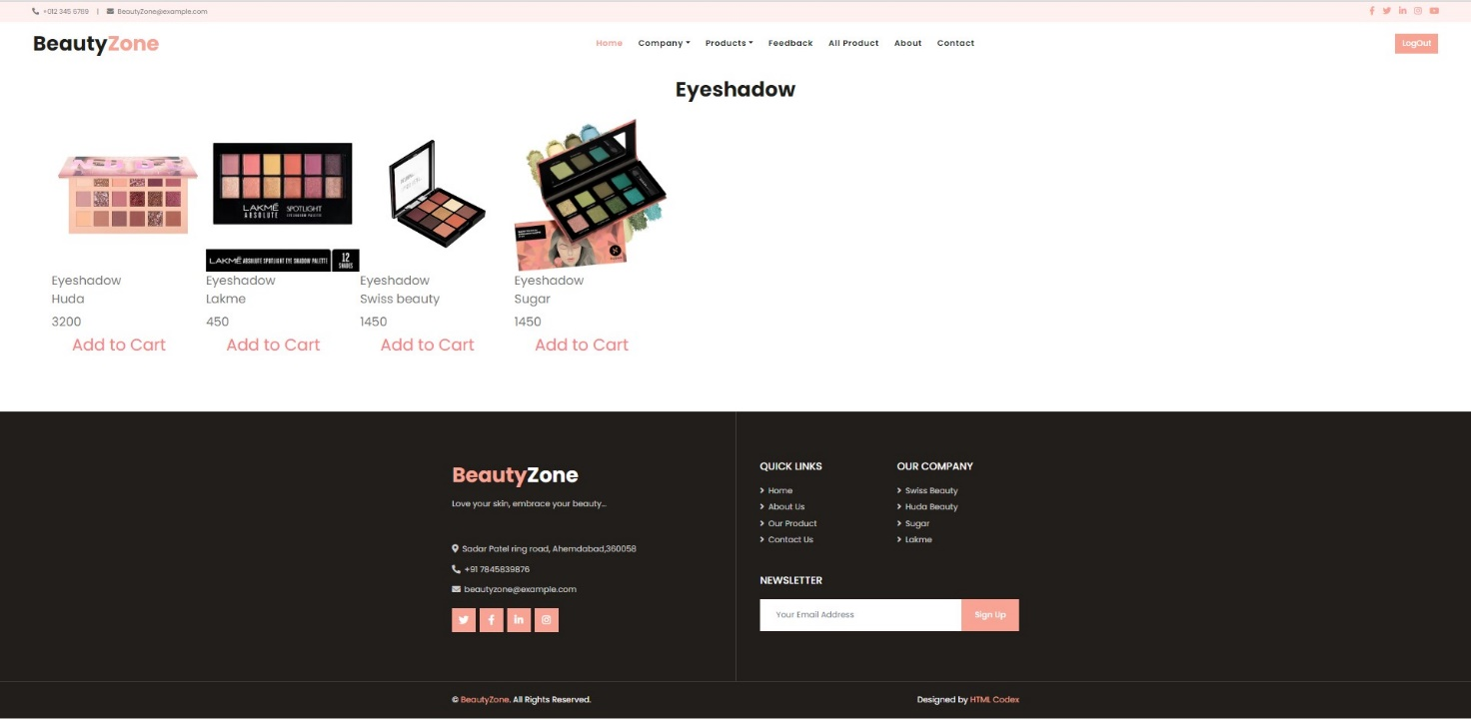**Form :- eyeshadow.php**

**Coding:-eyeshadow.php**

<?php

include("header1.php")

?>

<!-- items -->

<br>

<?php

include("con1.php");

$query="select *from items where itemname='Eyeshadow'";

$result=mysqli_query($con,$query);

echo"<table align='center' style='margin-left:100px'>

<h1 align='center'>Eyeshadow</h1>";

while($row=mysqli_fetch_array($result))

{

echo "<td>";

echo " <img src='image_project/$row[4]' height=300 width=300 >";

echo "<br>";

echo "<font size='+2'>";

echo $row["itemname"];

echo "<br>";

echo $row["company"];

echo "<br>";

echo $row["price"];

echo "</font>";

echo "<a href='addtocart.php?id=".$row[0]."'><font color='#FF8080' size='+3'><ul>Add to Cart</ul></font></a>";

echo "</td>";

}

echo"</tr>";

echo"<br>";

echo"</table>";

?>

<?php

include("footer1.php")

?>

**Form :- compact.php**

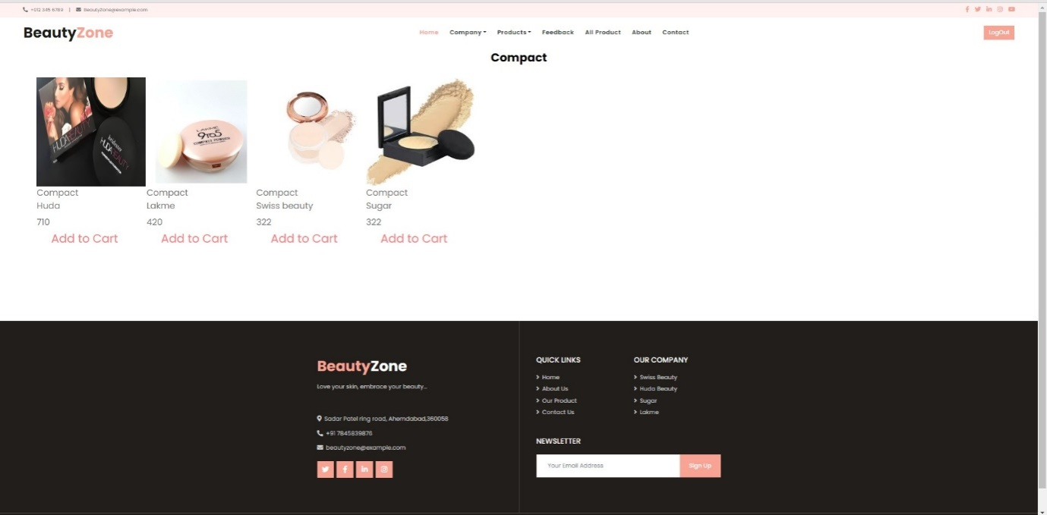

**Coding:-compact.php**

<?php

include("header1.php")

?>

<!-- items -->

<?php

include("con1.php");

$query="select *from items where itemname='Compact'";

$result=mysqli_query($con,$query);

echo"<table align='center' style='margin-left:100px'>

<h1 align='center'><font color='000000' size='+3'><b> Compact </b></font></h1>";

while($row=mysqli_fetch_array($result))

{

echo "<td>";

echo " <img src='image_project/$row[4]' height=300 width=300 >";

echo "<br>";

echo "<font size='+2'>";

echo $row["itemname"];

echo "<br>";

echo $row["company"];

echo "<br>";

echo $row["price"];

echo "</font>";

echo "<a href='addtocart.php?id=".$row[0]."'><font color='#FF8080' size='+3'><ul> Add to Cart <u></font></a>";

echo "</td>";

}

echo"</tr>";

echo"<br>";

echo"</table>";

?>

<br>

<br>

<br>

<br>

<?php

include("footer1.php")

?>

**Form :- addtocart.php**

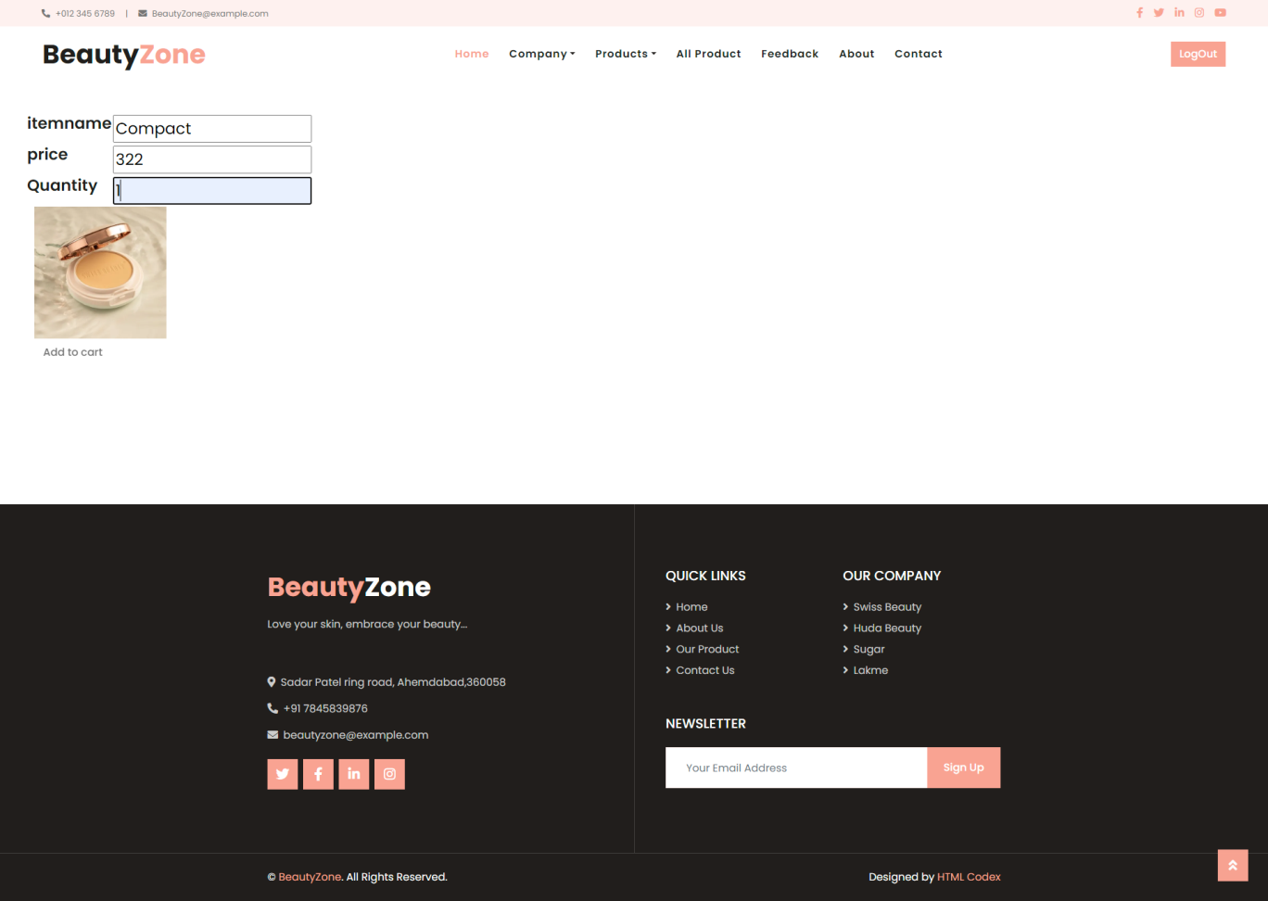

**Coding:- addtocart.php**

<?php

session_start();

if(!isset($_SESSION['username']))

header("location:login.php");

else

{

?>

<?php

include("header1.php")

?>

<?php

include("con1.php");

$id=$_GET['id'];

$query="select * from items where id=".$id;

$result=mysqli_query($con,$query);

while($row=mysqli_fetch_array($result))

{

?>

<form method="post" action="purchase.php">

<table>

<td>

<input type="hidden" name="id" value="<?php echo $id;?>"/>

<label><h4>&nbsp;&nbsp;&nbsp;&nbsp;&nbsp;&nbsp;&nbsp;itemname</h4></label>

</td>

<td><font size='+2'>

<input type="text" name="itemname" value="<?php echo $row['1'];?>"/>

</td>

</tr>

<tr>

<td>

<label><h4>&nbsp;&nbsp;&nbsp;&nbsp;&nbsp;&nbsp;&nbsp;price</h4></label>

</td>

<td><font size='+2'>

<input type="text"name="price" height="100%" value="<?php echo $row['3'];?>"/>

</td>

</tr>

<tr>

<td>

<label><h4>&nbsp;&nbsp;&nbsp;&nbsp;&nbsp;&nbsp;&nbsp;Quantity</h4></label>

</td>

<td><font size='+2'>

<input type="text" name="quantity" />

</td>

</tr>

<tr>

<td colspan="3">&nbsp;&nbsp;&nbsp;&nbsp;&nbsp;&nbsp;&nbsp;&nbsp;&nbsp;&nbsp;&nbsp;

<img src="<?php echo "image_project/$row[4]"?>" height=200 width=200 />

<?php

$img="image_project/$row[4]";

?>

<input type="hidden" name="image" value="<?php echo $img;?>"/>

</td>

</tr>

<br><br>

<tr>

<td colspan="2">&nbsp;&nbsp;&nbsp;&nbsp;&nbsp;&nbsp;&nbsp;&nbsp;&nbsp;&nbsp;&nbsp;

<input align="middle" name="Add to cart" type="submit" value="Add to cart" class="btn credit-btn box-shadow">

</td>

</tr>

</font>

</table>

</form>

</div>

</section><br><br><br><br><br>

<?php

}

?>

<?php

include("footer1.php")

?>

<?php }?>

**Form :- viewcart.php**

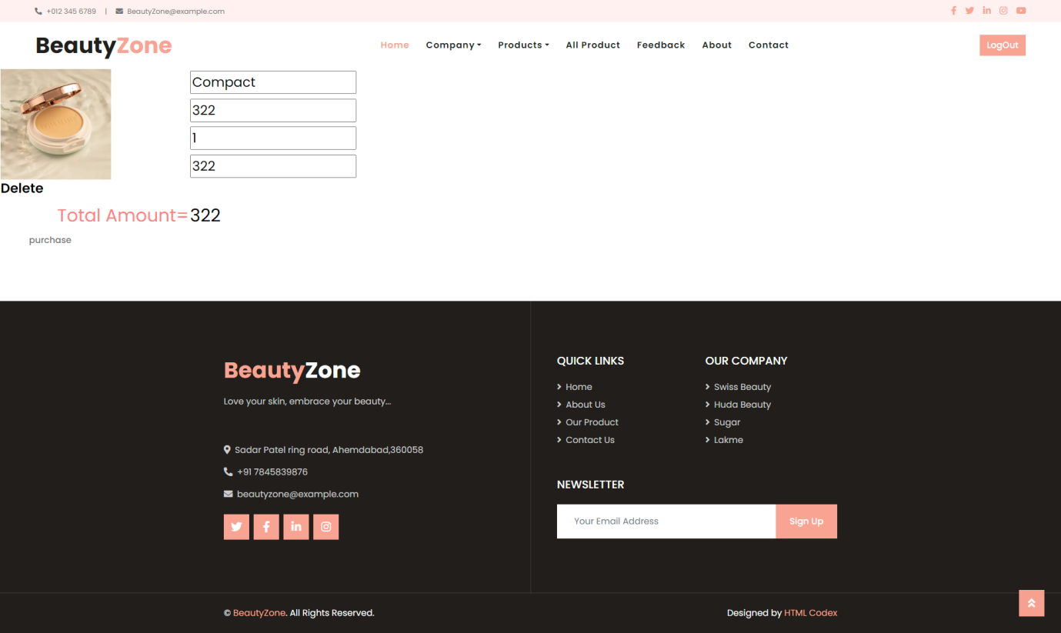

**Coding:- viewcart.php**

<?php

session_start();

if(!isset($_SESSION['username']))

header("location:login.php");

else

{

?>

<?php include("header1.php")?>

<script type="text/javascript">

function validateForm()

{

var a=document.forms["viewcart"]["quantity"].value;

if (a==null || a=="")

{

alert("quantity must be filled out");

return false;

}

</script>

<!-- ##### Call To Action Start ###### -->

<section class="cta-area d-flex flex-wrap">

<!-- Cta Thumbnail -->

<div class="cta-thumbnail bg-image jarallax" style="background-image: url(image/bg-image/21.jpg);"></div>

<!-- Cta Content -->

<form id="form1" method="post" action="deletecart.php">

<table>

<?php

include("con1.php");

$tot=0;

$username=$_SESSION['username'];

$query="select * from addtocart where username='$username'";

$result=mysqli_query($con,$query);

while($row=mysqli_fetch_array($result))

{

?>

<tr><td rowspan="5"><img src="<?php echo $row[5]?>" height=200 width=200></td></tr>

<tr><td><font color='black' size="+2"><input type="text" name="itemname" value="<?php echo $row[1];?>"></font></td></tr>

<tr><td><font size="+2"><input type="text"name="price"id="textfield"value="<?php echo $row[2];?>"/></td></tr>

<tr><td><font size="+2"><input type="text"name="quantity"id="textfield"value="<?php echo $row[3];?>"onSubmit="return validateForm()"/></td></tr>

<tr><td><font size="+2"><input type="text"name="tot"id="textfield"value="<?php echo $row[4];?>"/></td></tr>

<tr><td>

<?php echo "<a href='deletecartitem.php?id=".$row['0']."'><h4 ><font color='black'>Delete</font></h4></a>"?>

</td></tr>

<?php

$a=$row['4'];

$tot=$tot+$a;

?><?php

}

?>

<tr>

<td>&nbsp;&nbsp;&nbsp;&nbsp;&nbsp;&nbsp;&nbsp;&nbsp;&nbsp;&nbsp;&nbsp;&nbsp;&nbsp;&nbsp;&nbsp;&nbsp;&nbsp;&nbsp;&nbsp;&nbsp;&nbsp;&nbsp;&nbsp;&nbsp;<font color='#FF8080' size='+3'>Total Amount=</font>

<td><font color='black' size='+3'><?php echo $tot;?></font></td>

</tr>

<tr>

<td>&nbsp;&nbsp;&nbsp;&nbsp;&nbsp;&nbsp;&nbsp;&nbsp;

<input align="middle" name="submit" value="purchase"/id="bt" type="submit"class="btn credit-btn box-shadow">

</td>

</tr>

</table>

</form>

</div>

</section>

<?php include("footer1.php")?>

<?php }?>

**Coding:-purchase.php**

<?php

session_start();

if(!isset($_SESSION['username']))

header("location:login.php");

else

{

?>

<?php

include("con1.php");

$id=$_POST['id'];

$itemname=$_POST['itemname'];

$price=$_POST['price'];

$quantity=$_POST['quantity'];

$tot=$price*$quantity;

$username=$_SESSION['username'];

echo $tot;

$image=$_POST['image'];

$q="INSERT INTO `addtocart` (`itemname`, `price`, `quantity`, `total`, `image`, `username`)VALUES ('$itemname', '$price', '$quantity', '$tot', '$image', '$username');";

mysqli_query($con,$q);

header("location:viewcart.php");

?>

<?php }?>

**Form :- deletecart.php**



**Coding:-deletecart.php**

<?php

session_start();

if(!isset($_SESSION['username']))

header("location:login.php");

else

{

?>

<?php

include("con1.php");

$user=$_SESSION['username'];

$tot=$_POST['tot'];

$itemname=$_POST['itemname'];

$q1="select * from registration where username='$user'";

$res=mysqli_query($con,$q1);

while($row=mysqli_fetch_array($res))

{

$name= $row['1'];

$add=$row['2'];

$city= $row['3'];

}

mysqli_query($con,"INSERT INTO `purchase` (`name`, `address`, `city`, `itemname`, `total`, `payment`) VALUES ('$name', '$add', '$city', '$itemname', '$tot', '$tot');");

$q="delete from addtocart where username='$user'";

mysqli_query($con,$q);

//header("location:index.php");

?>

<script type="text/javascript">

alert("Congratulations! your order is conformed....");

window.location.href="index.php";

</script>

<?php

}

?>

**Coding:-deletecartitem.php**

<?php

session_start();

if(!isset($_SESSION['username']))

header("location:login.php");

else

{

?>

<?php

include("con1.php");

$id=$_GET['id'];

$user=$_SESSION['username'];

$q="delete from addtocart where id='$id'";

mysqli_query($con,$q);

header("location:viewcart.php");

?>

<script type="text/javascript">

alert("congratulations! your order is conformed...");

window.location="index.php";

</script>

<?php

}

?>

**Form :- login.php**

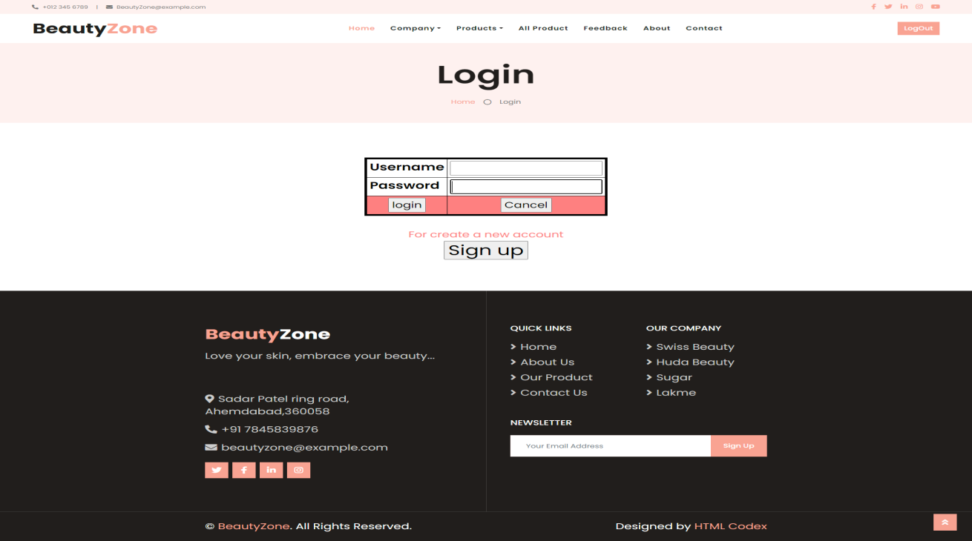

**Coding :- login.php**

<?php

include("header1.php")

?>

<!-- Header Start -->

<div class="bg-light" style="margin-bottom: 100px;">

<div class="container text-center py-5">

<h3 class="text-black display-3 mb-4">LOGIN</h3>

<div class="d-inline-flex align-items-center text-black">

<p class="m-0"><a class="text-black" href="">Home</a></p>

<i class="far fa-circle px-3"></i>

<p class="m-0">LOGIN</p>

</div>

</div>

</div>

<!-- Header End -->

<script type="text/javascript">

function validateForm()

{

var a=document.forms["login"]["username"].value;

var b=document.forms["login"]["password"].value;

if ((a==null || a=="") && (b==null || b==""))

if (a==null || a=="")

{

alert("username must be filled out");

return false;

}

if (b==null || b=="")

{

alert("password must be filled out");

return false;

}

if(b.length<5)

{

alert("password should be atleast 5 characters.");

return false;

}

if(!(b.match(/^[a-z,0-9][\w-]*$/i)))

{

alert("Password can not contain any special character or spaces except '_' or '-' . ");

return false;

}

}

</script>

<!-- ##### Newsletter Area Start ###### -->

<section class="newsletter-area section-padding-100 bg-img jarallax" style="background-image: url(file:///E|/hiral/project/Sample-Project&amp;workbook/POOJARA/project/client/img/bg-img/6.jpg);">

<div class="container">

<div class="row justify-content-center">

<div class="col-12 col-sm-10 col-lg-8">

<center>

<br>

<br>

<form action="checklogin.php" method="post" name="login"

onSubmit="return validateForm()">

<font size="+2" color="#FF8080">

<table align="center" size="80%"border="5" bordercolor="#000000" cellpadding="5" cellspacing="5" >

<tr>

<td><h3><font color="#000000">Username</font></h3></td>

<td><font size="+2"><input type="text" name="username" height="50%" width="60%"></font>

</td>

</tr>

<tr>

<td ><h3><font color="#000000">Password</font></h3></td>

<td><input type="password" name="password"></td>

</tr>

<tr>

<td align="center" bgcolor="#FF8080">

<input name="submit" type="submit" value="login">

</td>

<td align="center" bgcolor="#FF8080">

<input name="reset" type="reset" value="Cancel">

</td>

</tr>

</table>

</form>

</center>

<p> <font size="+2" color="FF8080">

<div align="center" class="style45" >For create a new account<h1><a href="registration.php">

<td align="center" bgcolor="#FF8080">

<input name="reset" type="reset" value="Sign up">

</td>

</div>

</div>

</div>

</div>

</section>

<?php

include("footer1.php")

?>

**Form:-registration.php**

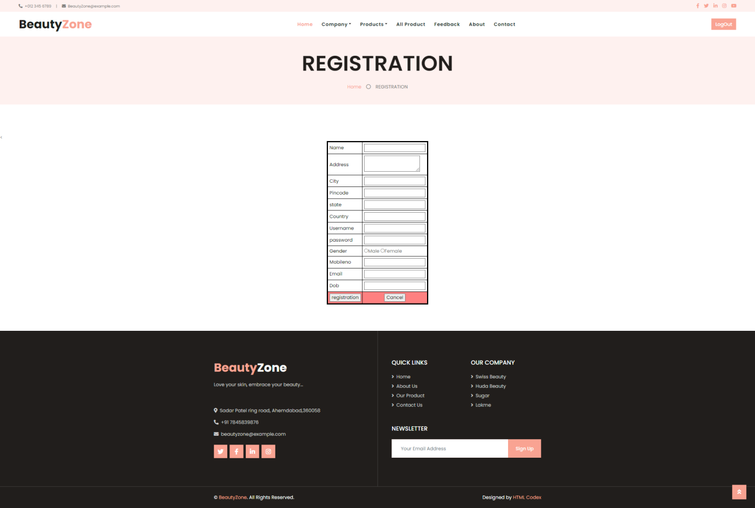

**Coding :- registration.php**

<?php

include("header1.php")

?>

<html>

<!-- Header Start -->

<div class="bg-light" style="margin-bottom: 100px;">

<div class="container text-center py-5">

<h3 class="text-black display-3 mb-4">REGISTRATION</h3>

<div class="d-inline-flex align-items-center text-black">

<p class="m-0"><a class="text-black" href="">Home</a></p>

<i class="far fa-circle px-3"></i>

<p class="m-0">REGISTRATION</p>

</div>

</div>

</div>

<!-- Header End -->

<

<form action="registrationsave.php" method="post" name="regi"

onSubmit="return validateForm()">

<table align="center" border="5" bordercolor="#000000" cellpadding="5" cellspacing="5">

<tr>

<td><font color="#000000"> Name </font></td>

<td><input type="text" name="nm"></td>

</tr>

<tr>

<td><font color="#000000"> Address </font></td>

<td><textarea name="address"></textarea></td>

</tr>

<tr>

<td><font color="#000000"> City </font></td>

<td><input type="text" name="city"></td>

</tr>

<tr>

<td><font color="#000000"> Pincode </font></td>

<td><input type="text" name="pincode"></td>

</tr>

<tr>

<td><font color="#000000"> state </font></td>

<td><input type="text" name="state"></td>

</tr>

<tr>

<td><font color="#000000"> Country </font></td>

<td><input type="text" name="country"></td>

</tr>

<tr>

<td><font color="#000000"> Username </font></td>

<td><input type="text" name="username"></td>

</tr>

<tr>

<td><font color="#000000"> password </font></td>

<td><input type="text" name="password"></td>

</tr>

<tr>

<td><font color="#000000"> Gender </font></td>

<td><input type="radio" name="gender" value="male">Male

<input type="radio" name="gender" value="female">Female</td>

</tr>

<tr>

<td><font color="#000000"> Mobileno</font></td>

<td><input type="text" name="mno"></td>

</tr>

<tr>

<td><font color="#000000"> Email </font></td>

<td><input type="text" name="email"></td>

</tr>

<tr>

<td><font color="#000000"> Dob </font></td>

<td><input type="text" name="dob"></td>

</tr>

<tr>

<td align="center" bgcolor="#FF8080">

<input name="submit" type="submit" value="registration">

</td>

<td align="center" bgcolor="#FF8080">

<input name="reset" type="reset" value="Cancel">

</td>

</table>

</body>

</html>

<?php

include("footer1.php")

?>

**Coding:-registrationsave.php**

<?php

include("con1.php");

$name=$_POST['nm'];

$address=$_POST['address'];

$city=$_POST['city'];

$pincode=$_POST['pincode'];

$state=$_POST['state'];

$country=$_POST['country'];

$username=$_POST['username'];

$password=$_POST['password'];

$gender=$_POST['gender'];

$mno=$_POST['mno'];

$email=$_POST['email'];

$dob=$_POST['dob'];

mysqli_query($con,"INSERT INTO `registration` (`name`, `address`, `city`,`pincode`, `state`, `country`, `username`, `password`, `gender`, `mobileno`, `email`, `dob`) VALUES ('$name', '$address', '$city', '$pincode', '$state', '$country', '$username', '$password', '$gender', '$mno', '$email', '$dob')");

header("location:index.php");

?>

**Form :- about.php**



**Coding :- about.php**

<?php include("header1.php"); ?>

<!-- Header Start -->

<div class="bg-light" style="margin-bottom: 100px;">

<div class="container text-center py-5">

<h3 class="text-black display-3 mb-4">About</h3>

<div class="d-inline-flex align-items-center text-black">

<p class="m-0"><a class="text-black" href="">Home</a></p>

<i class="far fa-circle px-3"></i>

<p class="m-0">About</p>

</div>

</div>

</div>

<!-- Header End -->

<!-- About Start -->

<div class="container-fluid py-5">

<div class="container py-5">

<div class="row align-items-center">

<div class="col-lg-6 pb-5 pb-lg-0">

<img class="img-fluid w-100" src="image_project/model1.jpg" alt="">

</div>

<div class="col-lg-6">

<h6 class="d-inline-block text-primary text-uppercase bg-light py-1 px-2">About

Us</h6>

<h1 class="mb-4">Best Beauty Products</h1><p class="pl-4 border-left border-primary"</p>

<div class="row pt-3">

<div class="col-6">

<div class="bg-light text-center p-4">

<h3 class="display-4 text-primary" data-toggle="counter-up">99</h3>

<h6 class="text-uppercase">Beauty Specialist</h6>

</div>

</div>

<div class="col-6">

<div class="bg-light text-center p-4">

<h3 class="display-4 text-primary" data-toggle="counter-up">999</h3>

<h6 class="text-uppercase">Happy Clients</h6>

</div>

</div>

</div>

</div>

</div>

</div>

</div>

<!-- About End -->

<!-- Team Start -->

<div class="container-fluid py-5">

<div class="container pt-5">

<div class="row justify-content-center text-center">

<div class="col-lg-6">

<h6 class="d-inline-block bg-light text-primary text-uppercase py-1 px-2s">Beauty

Specialist</h6>

<h1 class="mb-5">Makeup Expert & Beauty Specialist</h1>

</div>

</div>

<div class="row">

&nbsp;

<div class="col-lg-3 col-md-6">

<div class="team position-relative overflow-hidden mb-5">

<img class="img-fluid" src="image_project/modelv.jpg" alt="">

<div class="position-relative text-center">

<div class="team-text bg-primary text-white">

<h5 class="text-white text-uppercase">Vinisha Jethva</h5>

<p class="m-0"> Beauty Specialist</p>

</div>

<div class="team-social bg-dark text-center">

<a class="btn btn-outline-primary btn-square mr-2" href="#"><i class="fab fa-twitter"></i></a>

<a class="btn btn-outline-primary btn-square mr-2" href="#"><i class="fab fa-facebook-f"></i></a>

<a class="btn btn-outline-primary btn-square mr-2" href="#"><i class="fab fa-linkedin-in"></i></a>

<a class="btn btn-outline-primary btn-square" href="#"><i class="fab fa-instagram"></i></a>

</div>

</div>

</div>

</div>

<div class="col-lg-3 col-md-6">

<div class="team position-relative overflow-hidden mb-5">

<img class="img-fluid" src="image_project/feedback2.jpg" alt="">

<div class="position-relative text-center">

<div class="team-text bg-primary text-white">

<h5 class="text-white text-uppercase">Khushbu Kamriya</h5>

<p class="m-0">Makeup Expert</p>

</div>

<div class="team-social bg-dark text-center">

<a class="btn btn-outline-primary btn-square mr-2" href="#"><i class="fab fa-twitter"></i></a>

<a class="btn btn-outline-primary btn-square mr-2" href="#"><i class="fab fa-facebook-f"></i></a>

<a class="btn btn-outline-primary btn-square mr-2" href="#"><i class="fab fa-linkedin-in"></i></a>

<a class="btn btn-outline-primary btn-square" href="#"><i class="fab fa-instagram"></i></a>

</div>

</div>

</div>

</div>

&nbs;&nbsp;&nbsp&nbsp;&nbsp;

<div class="col-lg-3 col-md-6">

<div class="team position-relative overflow-hidden mb-5">

<img class="img-fluid" src="image_project/MODELL.jpg" alt="">

<div class="position-relative text-center">

<div class="team-text bg-primary text-white">

<h5 class="text-white text-uppercase">Hiral Dhola</h5>

<p class="m-0">Makeup Expert</p>

</div>

<div class="team-social bg-dark text-center">

<a class="btn btn-outline-primary btn-square mr-2" href="#"><i class="fab fa-twitter"></i></a>

<a class="btn btn-outline-primary btn-square mr-2" href="#"><i class="fab fa-facebook-f"></i></a>

<a class="btn btn-outline-primary btn-square mr-2" href="#"><i class="fab fa-linkedin-in"></i></a>

<a class="btn btn-outline-primary btn-square" href="#"><i class="fab fa-instagram"></i></a>

</div>

</div>

</div>

</div>

</div>

</div>

</div>

<!-- Team End -->

<?php include("footer1.php"); ?>

<?php include("header1.php"); ?>

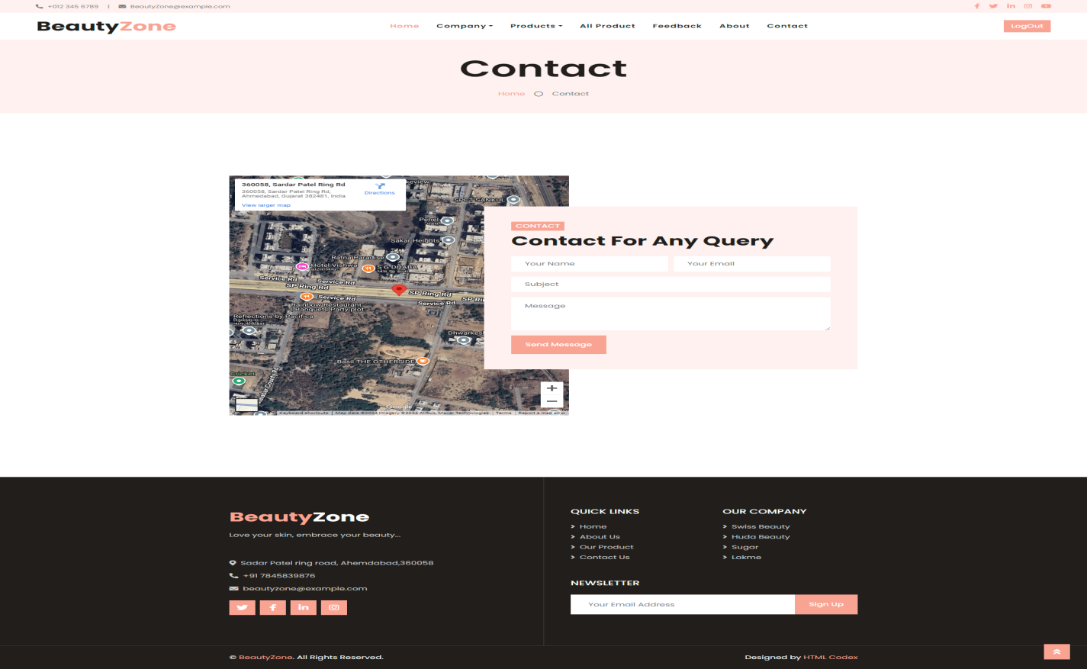**Form :- contactus.php**

Coding :- contactus.php

<?phpinclude("header1.php");

<!-- Header Start -->

<div class="bg-light" style="margin-bottom: 100px;">

<div class="container text-center py-5">

<h3 class="text-black display-3 mb-4">Contact</h3>

<div class="d-inline-flex align-items-center text-black">

<p class="m-0"><a class="text-black" href="">Home</a></p>

<i class="far fa-circle px-3"></i>

<p class="m-0">Contact</p>

</div>

</div>

</div>

<!-- Header End -->

<!-- Contact Start -->

<div class="container-fluid py-5">

<div class="container py-5">

<div class="row">

<div class="col-lg-6" style="min-height: 500px;">

<div class="position-relative h-100">

<iframe src="https://www.google.com/maps/embed?pb=!1m18!1m12!1m3!1d4514.543940709573!2d72.54962957601029!3d23.13503881212056!2m3!1f0!2f0!3f0!3m2!1i1024!2i768!4f13.1!3m3!1m2!1s0x395e82922c70b911%3A0x36d3c658cf9f6bc1!2s360058%2C%20Sardar%20Patel%20Ring%20Rd%2C%20Ahmedabad%2C%20Gujarat%20382481%2C%20India!5e1!3m2!1sen!2sbd!4v1723787477785!5m2!1sen!2sbd" width="600" height="750" style="border:0;" allowfullscreen="" loading="lazy" referrerpolicy="no-referrer-when-downgrade"></iframe>

</div>

</div>

<div class="col-lg-6 pt-5 pb-lg-5">

<div class="contact-form bg-light p-4 p-lg-5 my-lg-5">

<h6 class="d-inline-block text-white text-uppercase bg-primary py-1 px-2">Contact</h6>

<h1 class="mb-4">Contact For Any Query</h1>

<div id="success"></div>

<form name="sentMessage" id="contactForm" novalidate="novalidate">

<div class="form-row">

<div class="col-sm-6 control-group">

<input type="text" class="form-control border-0 p-4" id="name" placeholder="Your Name"

required="required" data-validation-required-message="Please enter your name" />

<p class="help-block text-danger"></p>

</div>

<div class="col-sm-6 control-group">

<input type="email" class="form-control border-0 p-4" id="email" placeholder="Your Email"

required="required" data-validation-required-message="Please enter your email" />

<p class="help-block text-danger"></p>

</div>

</div>

<div class="control-group">

<input type="text" class="form-control border-0 p-4" id="subject" placeholder="Subject"

required="required" data-validation-required-message="Please enter a subject" />

<p class="help-block text-danger"></p>

</div>

<div class="control-group">

<textarea class="form-control border-0 py-3 px-4" rows="3" id="message" placeholder="Message"

required="required"

data-validation-required-message="Please enter your message"></textarea>

<p class="help-block text-danger"></p>

</div>

<div>

<button class="btn btn-primary py-3 px-4" type="submit" id="sendMessageButton">Send

Message</button>

</div>

</form></div></div></div></div></div>

<!-- Contact End -->

<?php include("footer1.php"); ?>

**Form :- feedback.php**

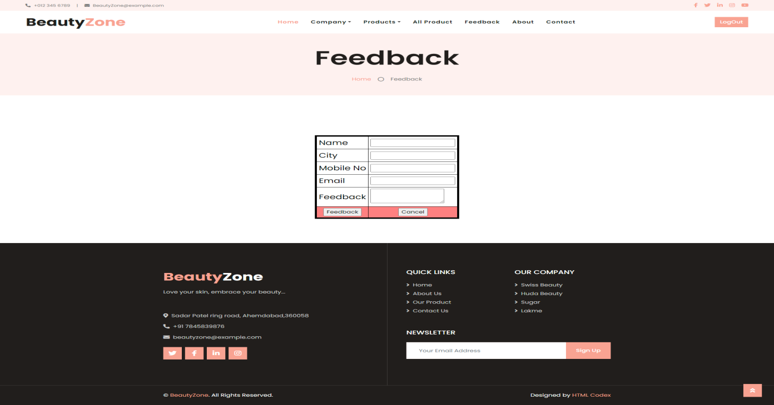

**Coding:- feedback.php**

<?php

include("header1.php")

?>

<!DOCTYPE html>

<head>

<meta charset="utf-8">

<meta http-equiv="X-UA-Compatible" content="IE=edge,chrome=1">

<title>BeautyZone</title>

<script type="text/javascript">

function validateForm()

{

var a=document.forms["feedback"]["nm"].value;

var b=document.forms["feedback"]["city"].value;

var c=document.forms["feedback"]["mno"].value;

var d=document.forms["feedback"]["email"].value;

var e=document.forms["feedback"]["feed"].value;

if ((a==null || a=="") && (b==null || b=="") && (c==null || c=="") && (d==null || d=="") &&

(e==null || e=="") )

{

alert("All Field must be filled out");

return false;

}

if (a==null || a=="")

{

alert("name must be filled out");

return false;

}

if (b==null || b=="")

{

alert("city must be filled out");

return false;

}

if (c==null || c=="")

{

alert("mno must be filled out");

return false;

}

if(!(c.match(/^\d{10}$/)))

{

alert("invalid mobile number");

return false;

}

if (d==null || d=="")

{

alert("email must be filled out");

return false;

}

if(!(d.match(/^[\w]+([_|\.-][\w]{1,})*@[\w]{2,}([_|\.-][\w]{1,})*\.([a-z]{2,4})$/)))

{

alert("enter valid email id");

return false;

}

if (e==null || e=="")

{

alert("feedback must be filled out");

return false;

}

}

</script>

<meta name="description" content="">

<meta name="keywords" content="">

<meta name="viewport" content="width=device-width">

<link rel="stylesheet" href="css/bootstrap.min.css">

<link rel="stylesheet" href="css/bootstrap-responsive.min.css">

<link rel="stylesheet" href="css/font-awesome.min.css">

<link rel="stylesheet" href="css/main.css">

<link rel="stylesheet" href="css/sl-slide.css">

<script src="js/vendor/modernizr-2.6.2-respond-1.1.0.min.js"></script>

<link rel="shortcut icon" href="img/g2.png">

</head>

<body>

<script src="js/vendor/jquery-1.9.1.min.js"></script>

<script src="js/main.js"></script>

<script src="js/jquery.ba-cond.min.js"></script>

<script src="js/jquery.slitslider.js"></script>

<!-- Slider -->

<script type="text/javascript">

$(function() {

var Page = (function() {

var $navArrows = $( '#nav-arrows' ),

slitslider = $( '#slider' ).slitslider( {

autoplay : true

} ),

init = function() {

initEvents();

},

initEvents = function() {

$navArrows.children( ':last' ).on( 'click', function() {

slitslider.next();

return false;

});

$navArrows.children( ':first' ).on( 'click', function() {

slitslider.previous();

return false;

});

};

return { init : init };

})();

Page.init();

});

</script>

<form action="feedbacksave.php" method="post" name="feedback" onSubmit="return validateForm()">

<!-- Header Start -->

<div class="bg-light" style="margin-bottom: 100px;">

<div class="container text-center py-5">

<h3 class="text-black display-3 mb-4">Feedback</h3>

<div class="d-inline-flex align-items-center text-black">

<p class="m-0"><a class="text-black" href="">Home</a></p>

<i class="far fa-circle px-3"></i>

<p class="m-0">Feedback</p>

</div>

</div>

</div>

<!-- Header End -->

<br><br>

<table align="center" border="5" bordercolor="#000000" cellpadding="5" cellspacing="5">

<tr>

<td><font size="+2" color="#000000">Name</td></font>

<td><input type="text" name="nm"></td>

</tr>

<tr>

<td><font size="+2" color="#000000">City</td>

<td><input type="text" name="city"></td>

</tr>

<tr>

<td><font size="+2" color="#000000">Mobile No</td>

<td><input type="text" name="mno"></td>

</tr>

<tr>

<td><font size="+2" color="#000000">Email</td>

<td><input type="text" name="email"></td>

</tr>

<tr>

<td><font size="+2" color="#000000">Feedback</td>

<td><textarea name="feed"></textarea></td>

</tr>

<tr>

<td align="center" bgcolor="#FF8080">

<input name="submit" type="submit" value="Feedback">

</td>

<td align="center" bgcolor="#FF8080">

<input name="reset" type="reset" value="Cancel">

</td>

</tr>

</table>

</form>

</body>

</html>

<?php

include("footer1.php")

?>

**Coding:- header.php**

<!DOCTYPE html>

<html lang="en">

<head>

<meta charset="utf-8">

<title>BeautyZone Beauty Products</title>

<meta content="width=device-width, initial-scale=1.0" name="viewport">

<meta content="Free HTML Templates" name="keywords">

<meta content="Free HTML Templates" name="description">

<!-- Favicon -->

<link href="img/favicon.ico" rel="icon">

<!-- Google Web Fonts -->

<link rel="preconnect" href="https://fonts.gstatic.com">

<link href="https://fonts.googleapis.com/css2?family=Poppins:wght@400;500;600;700&display=swap" rel="stylesheet">

<!-- Font Awesome -->

<link href="https://cdnjs.cloudflare.com/ajax/libs/font-awesome/5.10.0/css/all.min.css" rel="stylesheet">

<!-- Libraries Stylesheet -->

<link href="lib/animate/animate.min.css" rel="stylesheet">

<link href="lib/owlcarousel/assets/owl.carousel.min.css" rel="stylesheet">

<link href="lib/tempusdominus/css/tempusdominus-bootstrap-4.min.css" rel="stylesheet" />

<!-- Customized Bootstrap Stylesheet -->

<link href="css/style.css" rel="stylesheet">

</head>

<body>

<!-- Topbar Start -->

<div class="container-fluid bg-light d-none d-lg-block">

<div class="row py-2 px-lg-5">

<div class="col-lg-6 text-left mb-2 mb-lg-0">

<div class="d-inline-flex align-items-center">

<small><i class="fa fa-phone-alt mr-2"></i>+012 345 6789</small>

<small class="px-3">|</small>

<small><i class="fa fa-envelope mr-2"></i>BeautyZone@example.com</small>

</div>

</div>

<div class="col-lg-6 text-right">

<div class="d-inline-flex align-items-center">

<a class="text-primary px-2" href="">

<i class="fab fa-facebook-f"></i>

</a>

<a class="text-primary px-2" href="">

<i class="fab fa-twitter"></i>

</a>

<a class="text-primary px-2" href="">

<i class="fab fa-linkedin-in"></i>

</a>

<a class="text-primary px-2" href="">

<i class="fab fa-instagram"></i>

</a>

<a class="text-primary pl-2" href="">

<i class="fab fa-youtube"></i>

</a>

</div>

</div>

</div>

</div>

<!-- Topbar End -->

<!-- Navbar Start -->

<div class="container-fluid p-0">

<nav class="navbar navbar-expand-lg bg-white navbar-light py-3 py-lg-0 px-lg-5">

<a href="index.php" class="navbar-brand ml-lg-3">

<h1 class="m-0 text-primary"><span class="text-dark">Beauty</span>Zone</h1>

</a>

<button type="button" class="navbar-toggler" data-toggle="collapse" data-target="#navbarCollapse">

<span class="navbar-toggler-icon"></span>

</button>

<div class="collapse navbar-collapse justify-content-between px-lg-3" id="navbarCollapse">

<div class="navbar-nav m-auto py-0">

<a href="index.php" class="nav-item nav-link active">Home</a>

<div class="nav-item dropdown">

<a href="#" class="nav-link dropdown-toggle" data-toggle="dropdown">Company</a>

<div class="dropdown-menu rounded-0 m-0">

<a href="HUDA Beauty.php" class="dropdown-item">HUDA Beauty</a>

<a href="Swiss Beauty.php" class="dropdown-item">Swiss Beauty</a>

<a href="Lakme.php" class="dropdown-item">Lakme</a>

<a href="Sugar.php" class="dropdown-item">Sugar</a>

</div>

</div>

<div class="nav-item dropdown">

<a href="#" class="nav-link dropdown-toggle" data-toggle="dropdown">Products</a>

<div class="dropdown-menu rounded-0 m-0">

<a href="Foundation.php" class="dropdown-item">Foundation</a>

<a href="Compect.php" class="dropdown-item">Compect</a>

<a href="Eyeshadow.php" class="dropdown-item">Eyeshadow</a>

<a href="Lipstick.php" class="dropdown-item">Lipstick</a>

</div>

</div>

<a href="product.php" class="nav-item nav-link">All Product</a>

<a href="feedback.php" class="nav-item nav-link">Feedback</a>

<a href="about.php" class="nav-item nav-link">About</a>

<a href="contact.php" class="nav-item nav-link">Contact</a>

</div>

<a href="login.php" class="btn btn-primary d-none d-lg-block">LogOut</a>

</div>

</nav>

</div>

<!-- Navbar End -->

**Coding :- footer.php**

<!DOCTYPE html>

<html lang="en">

<head>

<meta charset="utf-8">

<title>BeautyZone Beauty Products</title>

<meta content="width=device-width, initial-scale=1.0" name="viewport">

<meta content="Free HTML Templates" name="keywords">

<meta content="Free HTML Templates" name="description">

<!-- Favicon -->

<link href="img/favicon.ico" rel="icon">

<!-- Google Web Fonts -->

<link rel="preconnect" href="https://fonts.gstatic.com">

<link href="https://fonts.googleapis.com/css2?family=Poppins:wght@400;500;600;700&display=swap" rel="stylesheet">

<!-- Font Awesome -->

<link href="https://cdnjs.cloudflare.com/ajax/libs/font-awesome/5.10.0/css/all.min.css" rel="stylesheet">

<!-- Libraries Stylesheet -->

<link href="lib/animate/animate.min.css" rel="stylesheet">

<link href="lib/owlcarousel/assets/owl.carousel.min.css" rel="stylesheet">

<link href="lib/tempusdominus/css/tempusdominus-bootstrap-4.min.css" rel="stylesheet" />

<!-- Customized Bootstrap Stylesheet -->

<link href="css/style.css" rel="stylesheet">

</head>

<body>

<!-- Footer Start -->

<div class="footer container-fluid position-relative bg-dark py-5" style="margin-top: 90px;">

<div class="container pt-5">

<div class="row">

<div class="col-lg-6 pr-lg-5 mb-5">

<a href="index.html" class="navbar-brand">

<h1 class="mb-3 text-white"><span class="text-primary">Beauty</span>Zone</h1>

</a>

<p>Love your skin, embrace your beauty...</p><br><br>

<p><i class="fa fa-map-marker-alt mr-2"></i>Sadar Patel ring road, Ahemdabad,360058</p>

<p><i class="fa fa-phone-alt mr-2"></i>+91 7845839876</p>

<p><i class="fa fa-envelope mr-2"></i>beautyzone@example.com</p>

<div class="d-flex justify-content-start mt-4">

<a class="btn btn-lg btn-primary btn-lg-square mr-2" href="#"><i class="fab fa-twitter"></i></a>

<a class="btn btn-lg btn-primary btn-lg-square mr-2" href="#"><i class="fab fa-facebook-f"></i></a>

<a class="btn btn-lg btn-primary btn-lg-square mr-2" href="#"><i class="fab fa-linkedin-in"></i></a>

<a class="btn btn-lg btn-primary btn-lg-square" href="#"><i class="fab fa-instagram"></i></a>

</div>

</div>

<div class="col-lg-6 pl-lg-5">

<div class="row">

<div class="col-sm-6 mb-5">

<h5 class="text-white text-uppercase mb-4">Quick Links</h5>

<div class="d-flex flex-column justify-content-start">

<a class="text-white-50 mb-2" href="index.php"><i class="fa fa-angle-right mr-2"></i>Home</a>

<a class="text-white-50 mb-2" href="about.php"><i class="fa fa-angle-right mr-2"></i>About Us</a>

<a class="text-white-50 mb-2" href="Product.php"><i class="fa fa-angle-right mr-2"></i>Our Product</a>

<a class="text-white-50" href="contact.php"><i class="fa fa-angle-right mr-2"></i>Contact Us</a>

</div>

</div>

<div class="col-sm-6 mb-5">

<h5 class="text-white text-uppercase mb-4">Our Company</h5>

<div class="d-flex flex-column justify-content-start">

<a class="text-white-50 mb-2" href="Swiss Beauty.php"><i class="fa fa-angle-right mr-2"></i>Swiss Beauty</a>

<a class="text-white-50 mb-2" href="Huda Beauty.php"><i class="fa fa-angle-right mr-2"></i>Huda Beauty</a>

<a class="text-white-50 mb-2" href="Sugar.php"><i class="fa fa-angle-right mr-2"></i>Sugar</a>

<a class="text-white-50 mb-2" href="Lakme.php"><i class="fa fa-angle-right mr-2"></i>Lakme</a>

</div>

</div>

<div class="col-sm-12 mb-5">

<h5 class="text-white text-uppercase mb-4">Newsletter</h5>

<div class="w-100">

<div class="input-group">

<input type="text" class="form-control border-light" style="padding: 30px;" placeholder="Your Email Address">

<div class="input-group-append">

<button class="btn btn-primary px-4">Sign Up</button>

</div>

</div>

</div>

</div>

</div>

</div>

</div>

</div>

</div>

<div class="container-fluid bg-dark text-light border-top py-4" style="border-color: rgba(256, 256, 256, .15) !important;">

<div class="container">

<div class="row">

<div class="col-md-6 text-center text-md-left mb-3 mb-md-0">

<p class="m-0 text-white">&copy; <a href="#">BeautyZone</a>. All Rights Reserved.</p>

</div>

<div class="col-md-6 text-center text-md-right">

<p class="m-0 text-white">Designed by <a href="https://htmlcodex.com">HTML Codex</a></p>

</div>

</div>

</div>

</div>

<!-- Footer End -->

<!-- Back to Top -->

<a href="#" class="btn btn-lg btn-primary back-to-top"><i class="fa fa-angle-double-up"></i></a>

<!-- JavaScript Libraries -->

<script src="https://code.jquery.com/jquery-3.4.1.min.js"></script>

<script src="https://stackpath.bootstrapcdn.com/bootstrap/4.4.1/js/bootstrap.bundle.min.js"></script>

<script src="lib/easing/easing.min.js"></script>

<script src="lib/waypoints/waypoints.min.js"></script>

<script src="lib/counterup/counterup.min.js"></script>

<script src="lib/owlcarousel/owl.carousel.min.js"></script>

<script src="lib/tempusdominus/js/moment.min.js"></script>

<script src="lib/tempusdominus/js/moment-timezone.min.js"></script>

<script src="lib/tempusdominus/js/tempusdominus-bootstrap-4.min.js"></script>

<!-- Contact Javascript File -->

<script src="mail/jqBootstrapValidation.min.js"></script>

<script src="mail/contact.js"></script>

<!-- Template Javascript -->

<script src="js/main.js"></script>

</body>

</html>

***TESTING***

***White-box Testing :***

White Box testing is used as an important primary testing approach. Code is tested using code scripts, driver etc that are employed to directly interface with and drive the code.

White-box testing, sometimes called glass-box testing is a test case design method that uses the control structure of the procedural design to derive test cases. White-box tests can be designed only after a component-level design (or source code) exists.

* Condition Testing.
* Unit Testing.

***Black-box Testing:***

In Black-Box Testing or Functional Testing, the output of the module and software, is taken into consideration, i.e. whether the software gives proper output as per the requirements or not. This can be done in Input, Interface Processing and Output Interface.

Black-box testing, also called behavioral testing, focuses on the functional requirements of the software. That is, black-box testing enables the software engineer to derive sets of input conditions that will fully exercise all functional requirements for a program**.**

***Test Case***

**Testcase of Registration form:**

|  |  |  |  |  |  |  |  |  |  |
| --- | --- | --- | --- | --- | --- | --- | --- | --- | --- |
| **No** | **Test Case** | **Description** | **Prerequisites** | **Input data** | **Severity** | **Priority** | **Expected Result** | **Actual Result** | **Pass /fail** |
| 1 | name | To check that name field have cursor | Internet should have available | - | Low-level | Low | Cursor should display in the fname | Cursor not able to display in the fname | Fail |
| 2 | Password  field | To check that  Password  Can contain  Space or  special character | Password  Must  Entered | mmmm  mmmm | High-level | High | Password  Can’t  Have  Space or  special character | Password  Have not  Space or  special character | pass |
| 3 | Mobile_no | To check  Minimum boundaryOf mo_no | Mobile_No | 1234567894 | Low-level | High | Mobile_No must be a 10 digit long. | Mobile_No is  10 digit  long | Pass |
| 4 | DOB | To check  That dob have dd-mm-yy formate | dd-mm-yy | - | Low-level | High | DOB  must entered digit or character | DOB is not valid  format | fail |
| 5 | Country | To check that Country have  character | Country must be enter | nnnrrrji | Low-level | High | Country Shoule  have  display  text area  format | Country  Display in  The text area | fail |
| 6 | User  name | To check user  Name can be left blank. | Internet | - | Low-level | Low | Username can’t be blank. | Username is blank | Fail |
| 7 | Email | To check that  email is valid  or not. | Internet should have available | ssssss | Low-level | Low | Email must  Be in valid  format | Email is not in valid  format | Fail |

**Testcase of Login form:**

|  |  |  |  |  |  |  |  |  |  |
| --- | --- | --- | --- | --- | --- | --- | --- | --- | --- |
| **No** | **Test Case** | **Desciption** | **Prerequisit** | **Input data** | **Serverity** | **Priority** | **Expected Result** | **Acutual Result** | **Pass /fail** |
| 1 | User name field | To check that User name field can’t be blank | Browser should have available | - | Lowlevel | Low | Should not blank the user name | Should not blank the user name | Pass |
| 2 | Password field | To check that user enter minimum 6 character. | Browser should have available | Riya9525 | Lowlevel | Low | User enter character and digit . | User enter character and digit. | pass |
| 3 | User name field | To check that user can’t enter first digit. | Browser should have available | 5855 | Lowlevel | Low | User can’t enter digit. | User can enter digit | Fail |
| 4 | Password field | To check that user can’t enter any special character. | Browser should have available | riddhikarangiya@ 25 | Lowlevel | Low | User can’I  Enter not space | User enter space | Fail |

***Future Enhancements***

* In our websites we provide cash on delivery because people will be hasisate for online payment.
* We give facilities to people send feedback to our site.
* The whole items gives by us.
* The user can purchase any items from case on delivery.
* In future we can change our template & also we will also put a new bridal item in this web-site.
* Also we will provide other item in this web-site.
* We will also add some new category.
* Inb future our web-site is change also.

***Conclusion***

* The important reason behind foundation of the store is that it is not time consuming as people across the world can also do BeautyZone of such kind of Lipstick,Foundation,ompact,Eyeshadow etc… products.
* Today’s life is so busy and people have no time for roaming in Malls for purchasing goods or products or any thing. So, to make life easy for people we make a small web service spoon,plate,bowl, bottel, kettle, cookpan, cooker, dishwasher and glass etc… purchasing.
* We have completed our project module base on using software engineering and system analysis and design approaches. Work we have done with preplanning seduling releted with time, constrains and result orientd progress in project development.

***BIBILIOGRAPHY***

* **Books Referred:**
* **Php Project BlackBook**
* **WebsitesVisited :**
* **www.amazon.com**
* [**www.flipkart.com**](http://www.flipkart.com)
* [**www.snapdeal.com**](http://www.snapdeal.com)
* **www.aliexpress.com**

